**GSI APU Card**

**Manufacturing Test Plan**

|  |  |
| --- | --- |
| **Document Information** | |
| **Model Name** | **GSI APU Card (QAOP-OAG-G)** |
| **Purpose** | **Manufacture Test Plan** |
| **Release Date** | **02/22/2021** |
| **Organization** | **Networking BG/WIBU** |
| **Release Version** | **2.7** |

Table of Contents

1 Revision History 4

2 System Overview 7

3 System Block Diagram 7

3.2 Test Strategy 7

3.3 Product Functional Test Coverage 8

4 Manufacture Test Flow Chart 9

5 Prepare Material 10

5.1 Procedure 10

6 Solder Paste 11

6.1 Procedure 11

7 SPI 12

7.1 Procedure 12

8 SMT Process 13

8.1 Procedure 13

9 AOI 14

9.1 Procedure 14

10 X-Ray 15

10.1 Procedure 15

11 Wavesolder Process 16

11.1 Procedure 16

12 ICT 17

12.1 Procedure 17

13 Assembly 18

13.1 Assembly following mechanical components: 18

14 PCBA Functional Test 20

14.1 Test Equipment List of Final Functional Test 20

14.2 Test Items of Final Functional Test 21

15 Burn-In 38

15.1 Test Equipment List of Burn-In 39

15.2 List of Test Items 39

15.3 Test Environment of Burn-In Test 41

15.4 Operating Profile 43

15.5 Test Requirement of Burn-In Test 43

16 Final Functional Test 44

16.1 Test Equipment List of Final Functional Test 44

16.2 Test Items of Final Functional Test 45

16.3 Test Environment of Final Functional Test 63

16.4 Test Requirements of Final Functional Test 64

17 FQC 65

17.1 Test Equipment of FQC 65

17.2 List of Test Items 67

17.3 Test Environment of FQC 69

17.4 Test Requirements of FQC 70

18 Firmware Upgrade 70

18.1 Equipment for Firmware Upgrade 70

18.2 Step by Step of how to upgrade the firmware 71

# Revision History

|  |  |  |  |
| --- | --- | --- | --- |
| Rev | Date | Description | Author |
| 0.1 | 2019/07/22 | Initial draft | Robin Yang  Jonathan Huang |
| 0.2 | 2020/01/03 | Modify Station name and test descript | Rodney Dou |
| 0.3 | 2020/01/15 | Add the PC spec. and test SOP | Jonathan Huang |
| 0.4 | 2020/01/22 | Add the FQC test flow | Jonathan Huang |
| 0.5 | 2020/02/05 | Add the pass screen for each items | Jonathan Huang |
| 0.7 | 2020/02/27 | Remove FAN check item | Jonathan Huang |
| 0.8 | 2020/03/06 | Add PCIe test in PCBA Final Function Test  Add Serial number check in FQC | Jonathan Huang |
| 0.9 | 2020/3/12 | FQC MAC address check change to 17.2.1.3 | Jonathan Huang |
| 1.0 | 2020/3/12 | Add Firmware upgrade on Chapter 18 | Jonathan Huang |
| 1.1 | 2020/3/13 | Correct some typo | Jonathan Huang |
| 1.2 | 2020/3/16 | Check Software version on 16.2.1.4 | Jonathan Huang |
| 1.3 | 2020/3/20 | Add Power off the Server after finished 16.2.1.19/16.2.1.20, 17.2.1.5 and 17.2.1.6. This items must be removed after customer implement Hot-Swap function. | Jonathan Huang |
| 1.4 | 2020/4/8 | Power on/off( or re-boot) the Server and DUT before 16.2.1.19/20  Upgrade to release: change to 16.2.1.21  Add Burn-In test  Software Version change  UART test | Jonathan Huang |
| 1.5 | 2020/04/09 | 13.1 Add the SW3 DIP Switch setting  14.2.1.1 SW3 check if the system can’t boot up  15.2.1.1 SW3 check if the system can’t boot up  16.2 remove SW3 check  17.2 remove SW3 check  16.2.1.15 clean the server test log  17.2.1.4 clean the server test log  16.2.1 remove All function test  14.2.1.3 eMMC SLC mode check | Jonathan Huang |
| 1.6 | 2020/04/22 | 16.2.1.3 Delete all Burn-In test log  16.2.1.5 RTC check spec. changed from +/-5sec to +/-15sec | Jonathan Huang |
| 1.7 | 2020/05/11 | 15.2.1.4 Burn-in status LED  PCIE test program version update  16.2.1.4 Software Version change  16.2.1.18 Check if Upgrade to release is ok  17.2.1. remove the PCIe test in FQC station  17.2.1.5 Verify the release version is workable | Jonathan Huang |
| 1.8 | 2020/05/26 | Remove 16.2.1.18 and 17.2.1.5, this test will be added in next GSI release code. | Jonathan Huang |
| 1.9 | 2020/06/23 | 16.2.1.18 Check if Upgrade to release is ok | Jonathan Huang |
| 2.0 | 2020/07/14 | 14.2.1.5 Check Software Version  14.2.1.10 Voltage check  14.2.1.11 I2C device list check  16.2.1.4 Check Software Version  16.2.1.18 Verify the release version  17.2.1.5 Verify the release version | Jonathan Huang |
| 2.1 | 2020/8/24 | 14.2.1.5 OCP/OCW/OTP value change and check  16.2.1.5 OCP/OCW/OTP value check | Jonathan Huang |
| 2.2 | 2020/8/28 | 14.2.1.5 OCP/OCW/OTP value change and check( write the user value into NVM)  14.2.1.12 I2C device list check(just record the list) | Jonathan Huang |
| 2.3 | 2020/8/28 | Remove 16.2.1.19, this will be tested only in FQC | Jonathan Huang |
| 2.4 | 2020/10/27 | 14.2.1.1 DIP switch photo update  14.2.1.6 Check Software Version(DUT)  14.2.1.11 Voltage check , more information need to record  15.1.1 DIP switch photo update  162.1.4Check Software Version(DUT)  17.2.1.2 Check Serial number & MAC (on DUT) del | Jonathan Huang |
| 2.5 | 2021/01/22 | 14.2.1.5 OCP/OCW/OTP value change and check  14.2.1.6 NINE POWER RAILS CHECK  14.2.1.7 Check Software Version(DUT)  14.2.1.9 MAC setting(on DUT)  14.2.1.10 Serial number setting(on DUT)  14.2.1.11 Board type setting(on DUT)  14.2.1.12 MAC, serial number, and board type check(on DUT)  14.2.1.13 Voltage check(on DUT)  14.2.1.14 I2C device list check(on DUT)  16.2.1.4 Check Software Version(DUT)  16.2.1.5 OCP/OCW/OTP value check  16.2.1.8 MAC, serial number, and board type check(on DUT) | Jonathan Huang |
| 2.6 | 2021/01/28 | 14.2.1.6 NINE POWER RAILS CHECK: power rail 0 spec modify  14.2.1.14 I2C device list check(on DUT)  17.2.1.1 QSPI code erase(on DUT, Golden sample doesn’t run this test)  14.2.1.7 Check Software Version(DUT)  16.2.1.4 Check Software Version(DUT) | Jonathan Huang |
| 2.7 | 2021/02/22 | 14.2.1.5 OCP/OCW/OTP value check  14.2.1.6 NINE POWER RAILS CHECK: power rail 0 spec modify  16.2.1.5 OCP/OCW/OTP value check | Jonathan Huang |
| 2.8 | 2021/02/23 | 16.2.1.18 Upgrade to release version(on DUT) | Jonathan Huang |

# System Overview

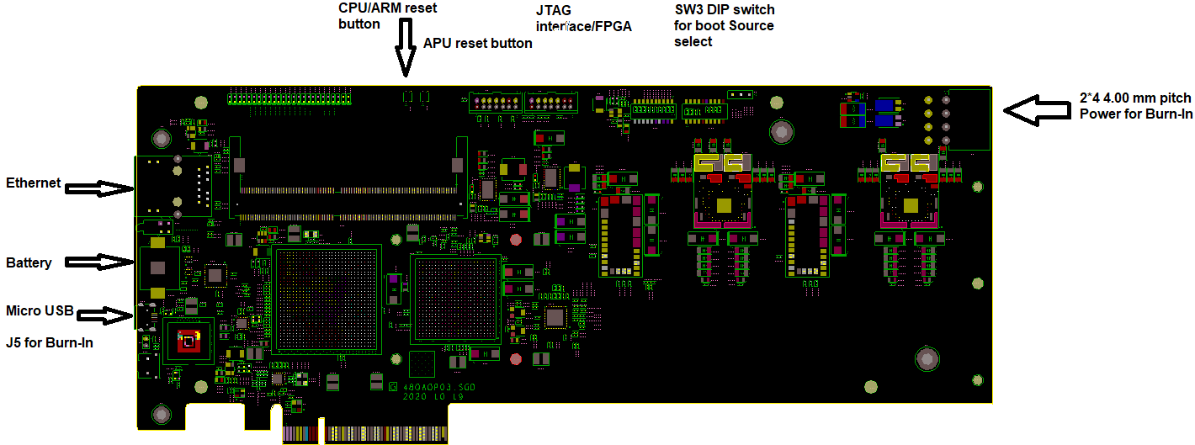

# System Block Diagram

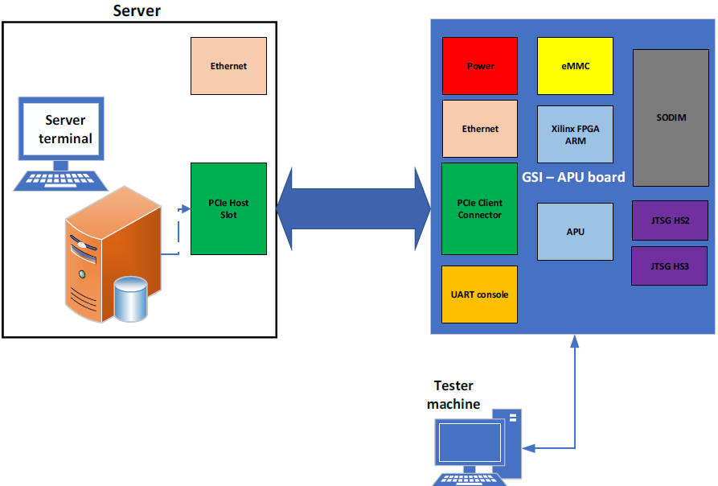

3.2 Test Strategy

|  |  |  |  |  |
| --- | --- | --- | --- | --- |
| **No.** | **Step** | **Process** | **Marking** | **Test Strategy** |
| 1 | Solder Paste Inspection | Y | SPI | 100% After Screen Printing |
| 2 | Auto Optical Inspection | Y | AOI | 100% after Reflow |
| 3 | X-ray Inspection | Y | X-ray | Mass Production: 2pcs/hrs (Sampling) |
| 4 | ICT/ Boundary Scan | Y | ICT/JTAG | 100% |
| 5 | PCBA Functional Test | Y |  | 100% |
| 6 | Burn-in Test | Y |  | 100%. |
| 7 | Final Functional Test | Y |  | 100% |
| 8 | FQC | Y |  | AQL: 0.65 |

## 3.3 Product Functional Test Coverage

|  |  |  |  |  |  |  |
| --- | --- | --- | --- | --- | --- | --- |
| **No.** | **Test Item** | **PCBA Functional Test** | **Burn-in** | **Final Functional Test** | **FQC** | **Remark** |
|  | SW3 DIP SWITCH checking | Y | Y |  |  |  |
|  | J5 jumper insert | X | Y | X | X |  |
|  | U-boot message check | Y |  |  |  |  |
|  | eMMC SLC Mode check | Y |  |  |  |  |
|  | Ethernet Test | Y |  | Y | Y |  |
| 1. c | Check software version | Y |  | Y |  |  |
|  | MAC setting | Y |  |  |  |  |
|  | Serial number setting | Y |  |  |  |  |
|  | MAC and serial number check | Y |  | Y | Y |  |
| 1. V | Voltage check | Y |  |  |  |  |
|  | I2C device list check | Y |  |  |  |  |
|  | RTC test | Y |  | Y | Y |  |
|  | UART Test | Y |  |  |  |  |
|  | All function test |  | Y |  |  |  |
|  | L4 to ARC testing |  | Y | Y |  |  |
|  | L4 to ARM testing |  | Y | Y |  |  |
|  | DB ARC to ARM all cores testing |  | Y | Y |  |  |
|  | DB ARM all cores testing |  | Y | Y |  |  |
|  | Mailbox ARC all cores testing |  | Y | Y |  |  |
| 1. L | LED blink testing |  |  | Y |  |  |
|  | PCIe test for L4 all 14GB |  |  | Y |  |  |
|  | PCIe test for L4 512MB |  |  | Y |  |  |
|  | Upgrade to release version |  |  | Y |  |  |
|  | Verify the release version |  |  | Y | Y |  |

# Manufacture Test Flow Chart

Solder Paste

Prepare Material

SPI

SMT Process

AOI

X-Ray

ICT

Assembly

PCBA Functional Test

Wavesolder

Process

Burn-In

Final Functional

Test

FQC

Packing

Ship

In Test Flow Chart, we defined the manufacturing functional test stage as following:

***PCBA Functional Test***: Functional test on PCBA.

***Burn-in:*** In order to ensure switch’s reliability and quality while used in various environments. Perform the burn-in test with functional test for checking the quality of component and processing.

***Final Functional Test***: Functional test after Burn-in process.

# Prepare Material

Solder Paste

Prepare Material

SPI

SMT Process

AOI

X-Ray

ICT

Assembly

PCBA Functional Test

Wavesolder

Process

Burn-In

Final Functional

Test

FQC

Packing

Ship

* 1. Procedure

1. Prepare a bar-coded label for main-board to indicate “WNC Serial Number”, “MAC Address”
2. Record all the Date-codes/Lot #s of all components for traceability
3. Use Shop-floor Data Collection System to timestamp all major process steps that the main-board goes thru. The system shall be capable of un-ambiguously connecting the process timestamps as well as the date-code/lot# of every component to the serial # of each board.
4. Pre-program the following components:

|  |  |  |  |  |
| --- | --- | --- | --- | --- |
| **Item** | **Chip** | **Description** | **WNC Part Number** | **Location** |
| 1 | eMMC | GSI FW Image | 72.50081.00U | U12 |
| 2 | UCD9090A | POWER MONITOR FW | 74.P9090.001 | U35 |

# Solder Paste

Solder Paste

Prepare Material

SPI

SMT Process

AOI

X-Ray

ICT

Assembly

PCBA Functional Test

Wavesolder

Process

Burn-In

Final Functional

Test

FQC

Packing

Ship

* 1. Procedure

1. Solder paste operation should be following *WNC ISO doc# 901-N11 "SMT Solder Paste Operation Instruction".*
2. Solder paste height should be following *WNC ISO doc# 901-N12 “SMT Solder Printing Operation Instruction”*.

# SPI

Solder Paste

Prepare Material

SPI

SMT Process

AOI

X-Ray

ICT

Assembly

PCBA Functional Test

Wavesolder

Process

Burn-In

Final Functional

Test

FQC

Packing

Ship

* 1. Procedure

1. Solder Paste Inspection, 100% sampling rate.
2. The solder paste height should meet *WNC ISO doc# 901-N12 “SMT Solder Printing Operation Instruction”*.

# SMT Process

Solder Paste

Prepare Material

SPI

SMT Process

AOI

X-Ray

ICT

Assembly

PCBA Functional Test

Wavesolder

Process

Burn-In

Final Functional

Test

FQC

Packing

Ship

* 1. Procedure

1. Make sure IR profile meet components thermal specification.

# AOI

Solder Paste

Prepare Material

SPI

SMT Process

AOI

X-Ray

ICT

Assembly

PCBA Functional Test

Wavesolder

Process

Burn-In

Final Functional

Test

FQC

Packing

Ship

* 1. Procedure

1. All boards shall undergo Automated Optical Inspection for the verification of component type and location, orientation.

# X-Ray

Solder Paste

Prepare Material

SPI

SMT Process

AOI

X-Ray

ICT

Assembly

PCBA Functional Test

Wavesolder

Process

Burn-In

Final Functional

Test

FQC

Packing

Ship

* 1. Procedure

1. X-Ray Check for solder joint, 2pcs/2hr sample rate for MP.

# Wavesolder Process

Solder Paste

Prepare Material

SPI

SMT Process

AOI

X-Ray

ICT

Assembly

PCBA Functional Test

Wavesolder

Process

Burn-In

Final Functional

Test

FQC

Packing

Ship

* 1. Procedure

1. TBD

# ICT

Solder Paste

Prepare Material

SPI

SMT Process

AOI

X-Ray

ICT

Assembly

PCBA Functional Test

Wavesolder

Process

Burn-In

Final Functional

Test

FQC

Packing

Ship

* 1. Procedure

TBD

# Assembly

Solder Paste

Prepare Material

SPI

SMT Process

AOI

X-Ray

ICT

Assembly

PCBA Functional Test

Wavesolder

Process

Burn-In

Final Functional

Test

FQC

Packing

Ship

* 1. Assembly following mechanical components:

|  |  |  |  |  |
| --- | --- | --- | --- | --- |
| **Item** | **Components** | **Description** | **WNC Part Number** | **Location** |
|  | Heatsink for 1 Slot | 1 slot heatsink with 4 screws | 3E.00009.111ST |  |
|  | Bracket for 1 Slot | 1 slot bracket | 3S.0014A.111ST |  |
|  | Screw for PCIe bracket | 1 slot bracket screw | 86.00A83.A20 |  |
|  | Battery | LR44 button cell battery | 28.50044.002 | BAT1 |
|  | SODIMM module | DDR4 SODIMM | 56.0QAOP.001 | U18 |
|  | SW3 DIP switch adjust | SW3 setting must be:  10 /9 /8 /7 /6 /5 /4 /3 /2 /1  OFF/ON/OFF/ON/ON/OFF/ON/OFF/OFF/ON |  | SW3 |

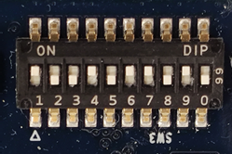

# PCBA Functional Test

Solder Paste

Prepare Material

SPI

SMT Process

AOI

X-Ray

ICT

Assembly

PCBA Functional Test

Wavesolder

Process

Burn-In

Final Functional

Test

FQC

Packing

Ship

* 1. Test Equipment List of Final Functional Test

|  |  |  |  |  |
| --- | --- | --- | --- | --- |
| ***Item*** | ***Equipment*** | ***Specification*** | ***Qty*** | ***Remark*** |
| 1 | PC | 1. OS: Ubuntu 16.04 or 18 LTS 2. HW spec.:   PCIe Gen.3 X16  BIOS support: Above 4GB decoding   1. This compute must access the internet for package update | 1 | The Ubuntu update package:  sudo apt install dialog  sudo update-pciids  Driver: CP210x_Universal Driver |
| 2 | Barcode Scanner | 2D | 1 |  |
| 3 | Com port setting | Baud: 115200, HW SW flow control “NO” |  |  |
| 3 | PCIe Hotswap Card | PEX-16-50185 | 1 |  |
| 4 | PCIe Extenend Card | PEX-16XL V3.0 | 1 |  |
| 5 | RJ45 Cable | Ethernet Cable 3m | 1 |  |
| 6 | Console Cable | USB type-A to Micro-USB console cable | 1 |  |
| 7 | DHCP server | Need a DHCP server for DUT to do Ethernet test | 1 |  |

* 1. Test Items of Final Functional Test

|  |  |  |  |
| --- | --- | --- | --- |
| **Item** | **Test Feature** | **Detailed Description** | **Remark** |
|  | Check SW3 setting if test is fail(need to disassemble the HeatSink) | Booting up from eMMC, SW3 setting as below:  10 /9 /8 /7 /6 /5 /4 /3 /2 /1 OFF/ON/OFF/ON/ON/OFF/ON/OFF/OFF/ON | 14.2.1.1 |
|  | u-Boot message check | Check the u-boot message | 14.2.1.2 |
|  | Ethernet Test | Ethernet connection test | 14.2.1.3 |
|  | Software version check | To check the GSI software version | 14.2.1.4 |
|  | Run standalone test program | Run the GSI standalone test program | 14.2.1.5 |
|  | MAC setting | Choose option 8 as test4, then option 1 for MAC address setting | 14.2.1.6 |
|  | Serial number setting | Choose option 8 as test4, then option2 for MAC address setting | 14.2.1.7 |
|  | MAC and serial number check | Choose option 8 as test4, then option4 for check the MAC and serial setting in test6 and test7 | 14.2.1.8 |
|  | RTC test | Run Option #2 test 20 for RTC function test | 14.2.1.9 |
|  | UART test | Run Option #2 test 23 for UART function test | 14.2.1.10 |

* + - 1. SW3 DIP switch setting(on DUT)

If the system can’t boot up, then please disassemble the HeatSink and check the SW3 configuration.

1 / 2 / 3 / 4 / 5 / 6 / 7 / 8 / 9 / 10

ON / OFF / OFF / ON / OFF / ON / ON / OFF / ON / OFF



* + - 1. U-boot message check(on DUT)

“Hit any key to stop autoboot: 4”, Press ‘enter’ to stop uboot into prompt.

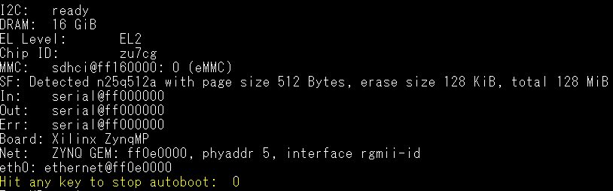

If it is successful to stop at u-boot command line mode, the screen will be as below.

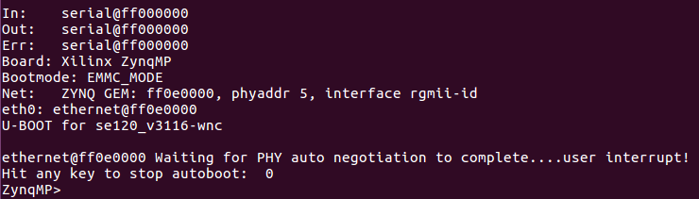

Press ‘print’ to show ENV variables. Check below marked yellow parameters.

arch=arm

autoload=no

baudrate=115200

board=zynqmp

board_name=zynqmp

boot_img=BOOT.BIN

boot_targets=mmc0

bootcmd=run default_bootcmd

bootdelay=4

bootenv=uEnv.txt

bootenvsize=0x40000

bootenvstart=0x100000

clobstart=0x10000000

console=console=ttyPS0,115200

cp_kernel2ram=mmcinfo && fatload mmc ${sdbootdev} ${netstart} ${kernel_img}

cpu=armv8

default_bootcmd=run uenvboot; run cp_kernel2ram && bootm ${netstart}

dtb_img=system.dtb

dtbnetstart=0x23fff000

eraseenv=sf probe 0 && sf erase ${bootenvstart} ${bootenvsize}

ethact=ethernet@ff0e0000

ethaddr=00:0a:35:00:ee:00

fault=echo ${img} image size is greater than allocated place - partition ${img} is NOT UPDATED

fdtcontroladdr=7fe7f920

gsi_bootcmd=123456789

importbootenv=echo "Importing environment from SD ..."; env import -t ${loadbootenv_addr} $filesize

* + - 1. eMMC SLC Mode Check

Press ‘mmc info’ to show the eMMC configuration. Check below marked yellow parameters.

ZynqMP> mmc info

Device: sdhci@ff160000

Manufacturer ID: 13

OEM: 14e

Name: Q2J55

Tran Speed: 200000000

Rd Block Len: 512

MMC version 5.0

High Capacity: Yes

Capacity: 3.6 GiB

Bus Width: 4-bit

Erase Group Size: 512 KiB

HC WP Group Size: 8 MiB

User Capacity: 3.6 GiB ENH WRREL

User Enhanced Start: 0 Bytes

User Enhanced Size: 3.6 GiB

Boot Capacity: 2 MiB ENH

RPMB Capacity: 4 MiB ENH

If the test is passed, then press ‘bootm’ to boot the system to Linux for next test.

* + - 1. Ethernet Test(on DUT)

You could press <Ctrl-C> to stop load gsi-cli application (when you see 15% … , 50% icons on screen and so on).

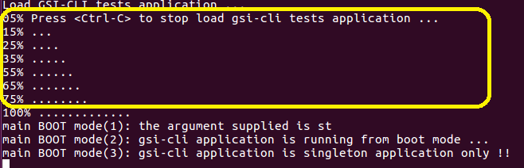

#ifconfig

Please confirm that the IP address is the same network domain as the PC we use.

Ex: PC IP address: 192.168.33.60, DUT IP address:192.168.33.125

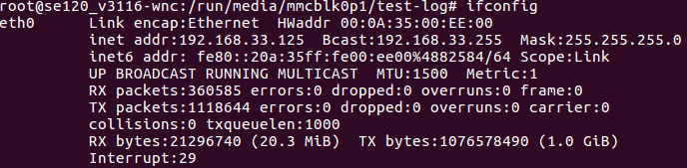

#ping 192.168.33.60 –c 10

The test result must be 0% packet lost as below.

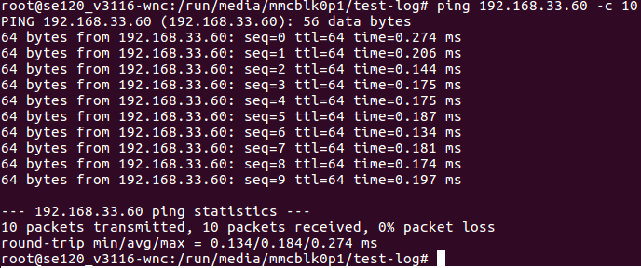

After finished this test, run below command to make sure the test program is not running.

#sh /run/media/mmcblk0p1/scripts/stop_gsi_cli_test_app.sh

* + - 1. OCP/OCW/OTP value change and check

Setting command

#i2cset -f -y 1 0x19 0x46 0xea80 w

#i2cset -f -y 1 0x19 0x4a 0xea40 w

#i2cset -f -y 1 0x19 0x4f 0xeb98 w

#i2cset -f -y 1 0x19 0x21 0x2000 w

#i2cset -f -y 1 0x19 0x15

#i2cset -f -y 1 0x1A 0x46 0xea80 w

#i2cset -f -y 1 0x1A 0x4a 0xea40 w

#i2cset -f -y 1 0x1A 0x4f 0xeb98 w

#i2cset -f -y 1 0x1A 0x21 0x2000 w

#i2cset -f -y 1 0x1A 0x15

Check command

#i2cget -f -y 1 0x19 0x46 w

0xea80

#i2cget -f -y 1 0x19 0x4a w

0xea40

#i2cget -f -y 1 0x19 0x4f w

0xeb98

#i2cget -f -y 1 0x19 0x21 w

0x2000

#i2cget -f -y 1 0x1A 0x46 w

0xea80

#i2cget -f -y 1 0x1A 0x4a w

0xea40

#i2cget -f -y 1 0x1A 0x4f w

0xeb98

#i2cget -f -y 1 0x1A 0x21 w

0x2000

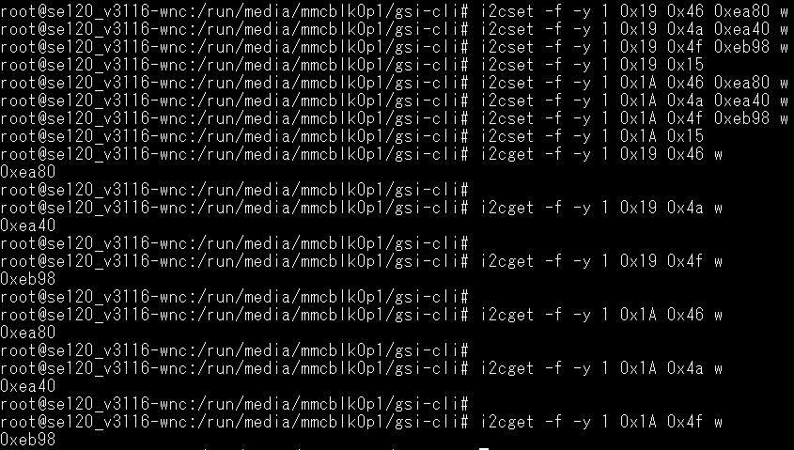

* + - 1. NINE POWER RAILS CHECK

#sh /run/media/mmcblk0p1/scripts/mon_board_params_i2c_test.sh -p 10 -n 2

The rail exponent decimal is

==============================

The power rail is 0

voltage hex value for ten times

time delay is 1 sec between each read

==============================

exponent value=

0x16

0x2f40

0x2f40

==============================

The power rail is 1

voltage hex value for ten times

time delay is 1 sec between each read

==============================

exponent value=

0x13

0x3aac

0x3a7a

==============================

The power rail is 2

voltage hex value for ten times

time delay is 1 sec between each read

==============================

exponent value=

0x13

0x4fcd

0x4fd4

==============================

The power rail is 3

voltage hex value for ten times

time delay is 1 sec between each read

==============================

exponent value=

0x12

0x3748

0x3770

==============================

The power rail is 4

voltage hex value for ten times

time delay is 1 sec between each read

==============================

exponent value=

0x12

0x4cf4

0x4d28

==============================

The power rail is 5

voltage hex value for ten times

time delay is 1 sec between each read

==============================

exponent value=

0x12

0x3ca0

0x3cdc

==============================

The power rail is 6

voltage hex value for ten times

time delay is 1 sec between each read

==============================

exponent value=

0x12

0x35b8

0x35ac

==============================

The power rail is 7

voltage hex value for ten times

time delay is 1 sec between each read

==============================

exponent value=

0x12

0x396c

0x39a8

==============================

The power rail is 8

voltage hex value for ten times

time delay is 1 sec between each read

==============================

exponent value=

0x11

0x4c08

0x4ba0

==============================

The power rail is 9

voltage hex value for ten times

time delay is 1 sec between each read

==============================

exponent value=

0x12

0x0000

0x0000

==============================

current hex value for ten times

time delay is 1 sec between each read

the current format is linear11, total hex is 16bit, MSB 5bit is 2's complement.

11bits*2^(-?)=

==============================

exponent value=

0xbb10

0xbb08

Pass criteria: power rail 0~8 must be in the below hex range:

The power rail 0: 0x2c00 ~ 0x3266

The power rail 1: 0x36b8 ~ 0x3c7a

The power rail 2: 0x4C00 ~ 0x5400

The power rail 3: 0x33b6 ~ 0x3916

The power rail 4: 0x4a7e ~ 0x4f1a

The power rail 5: 0x3999 ~ 0x4333

The power rail 6: 0x3418 ~ 0x375c

The power rail 7: 0x36b8 ~ 0x3c7a

The power rail 8: 0x4a7e ~ 0x4f1a

* + - 1. Check Software Version(DUT)

#cat /run/media/mmcblk0p1/version-image-gsi-tests-leda-e

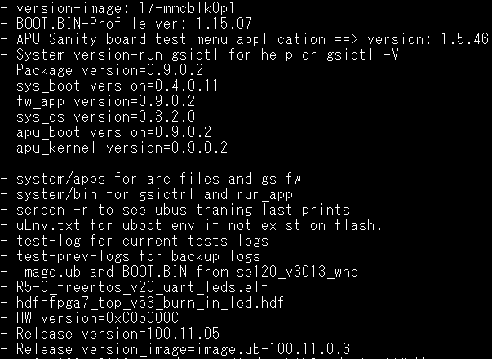

- version-image: 17-mmcblk0p1

- BOOT.BIN-Profile ver: 1.15.07

- APU Sanity board test menu application ==> version: 1.5.46

- System version-run gsictl for help or gsictl -V

Package version=0.9.0.2

sys_boot version=0.4.0.11

fw_app version=0.9.0.2

sys_os version=0.3.2.0

apu_boot version=0.9.0.2

apu_kernel version=0.9.0.2

- system/apps for arc files and gsifw

- system/bin for gsictrl and run_app

- screen -r to see ubus traning last prints

- uEnv.txt for uboot env if not exist on flash.

- test-log for current tests logs

- test-prev-logs for backup logs

- image.ub and BOOT.BIN from se120_v3013_wnc

- R5-0_freertos_v20_uart_leds.elf

- hdf=fpga7_top_v53_burn_in_led.hdf

- HW version=0xC05000C

- Release version=100.11.05

- Release version_image=image.ub-100.11.0.6

* + - 1. Run standalone test program(on DUT)

# cd /run/media/mmcblk0p1/gsi-cli/

# ./target-test

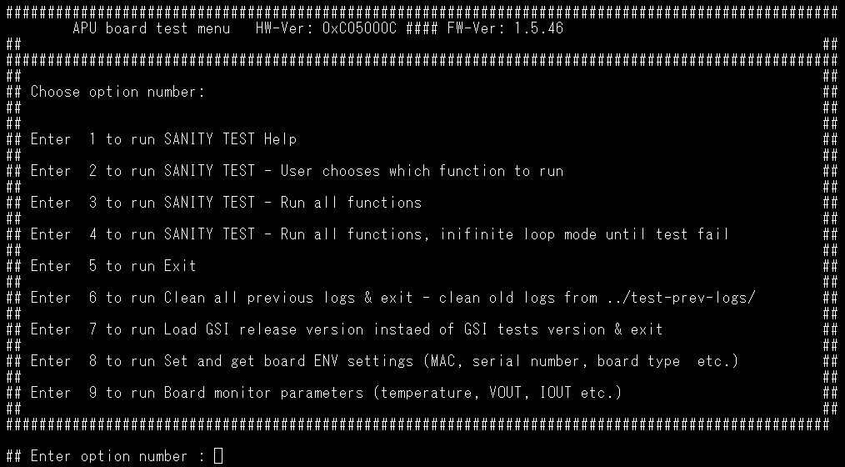

* + - 1. MAC setting(on DUT)

Follow test4. , choose option 8, then chose option 1 for MAC setting as below



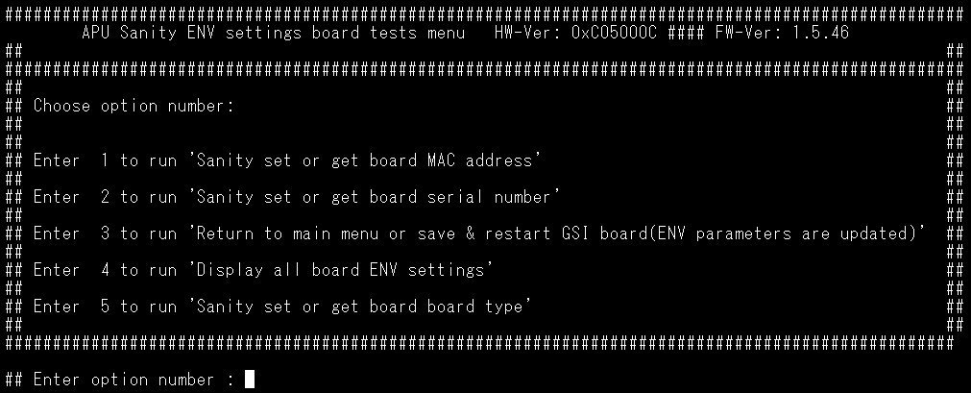

Select ‘1’ to set or get MAC address, the MAC address should be 70:B3:D5:2A:6x:xx

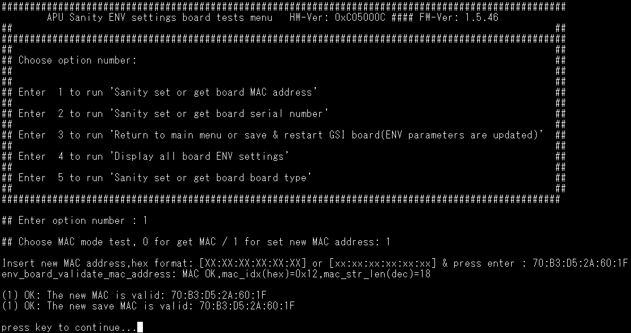

* + - 1. Serial number setting(on DUT)

Follow test4. , choose option 8 for ENV setting as below.





Select ‘2’ to set or get serial number, then input 1 for setting the new serial number.

The board serial number will be “ GSI-RnD-lab-ID-board number” as below.

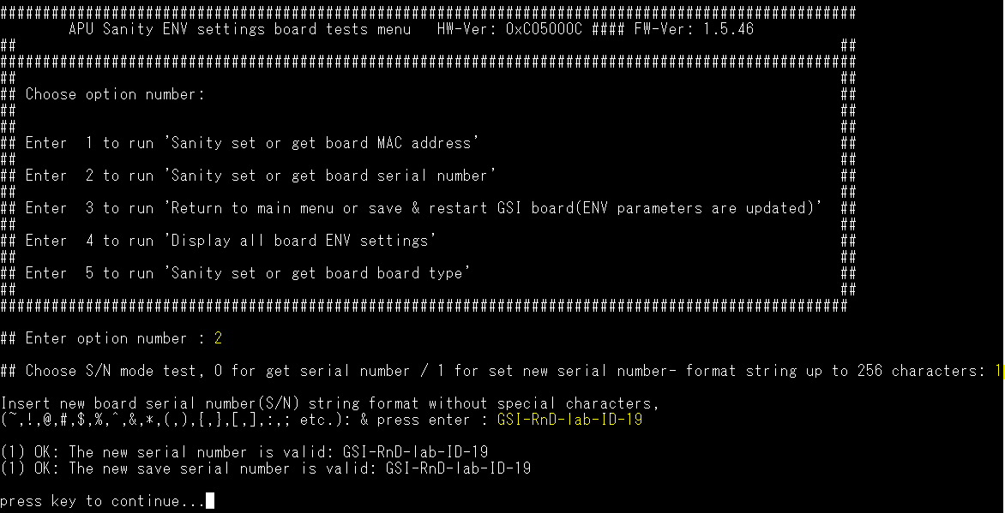

* + - 1. Board type setting(on DUT)

Follow test4. , choose option 8 for ENV setting as below.





Select ‘5’ to set or get the board type, then input 1 for setting the board type.

The board type will be “LEDA-E” as below. (The old shorter board should be LEDA-G)

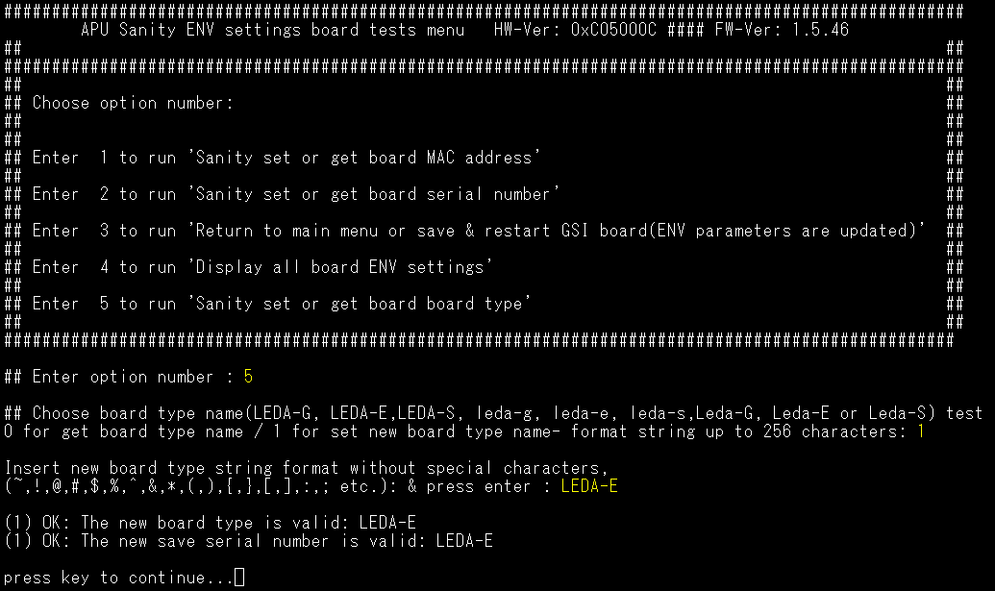

Press Enter, the select ‘3’ to return to main menu or save new ENV parameters.

If ENV parameters are changed (status != 0), new value is set and restart the board.

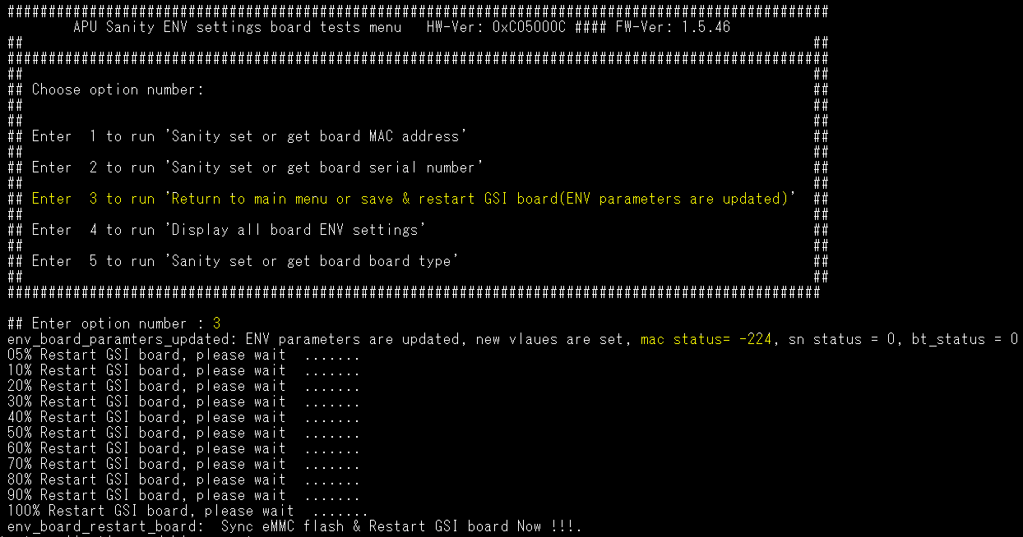

The system will reboot, just wait the system run to the test program as below screen.



* + - 1. MAC and serial number check(on DUT)

Choose option 8, then chose option 4 for MAC, serial number, and board type checking



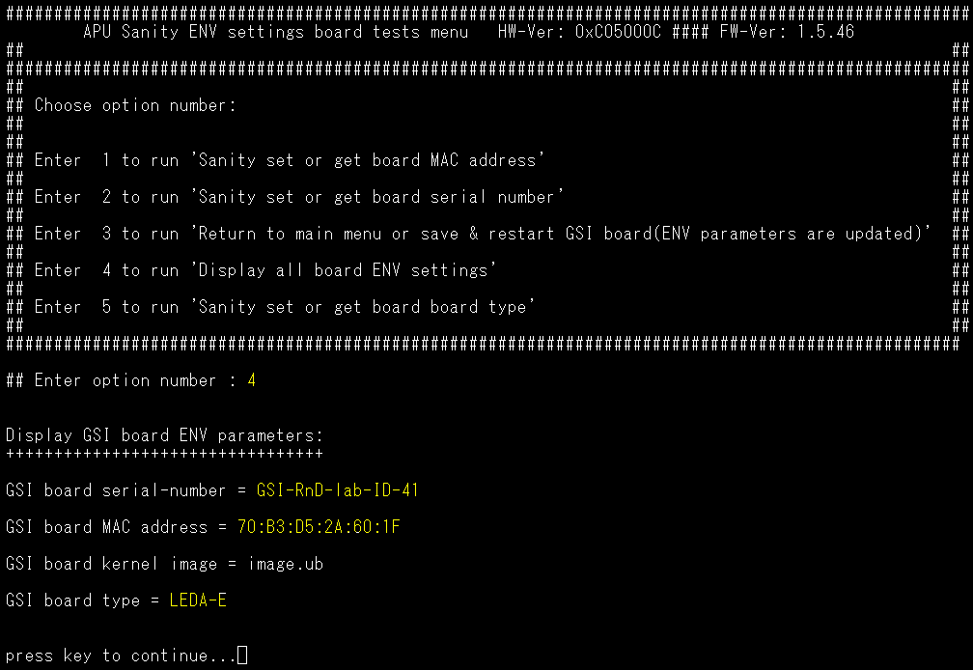

The MAC address, serial number, and board type must be the same as you set before.

* + - 1. Voltage check(on DUT)

Choose option 9, then input 1 for voltage value check. The pass criteria is as below.

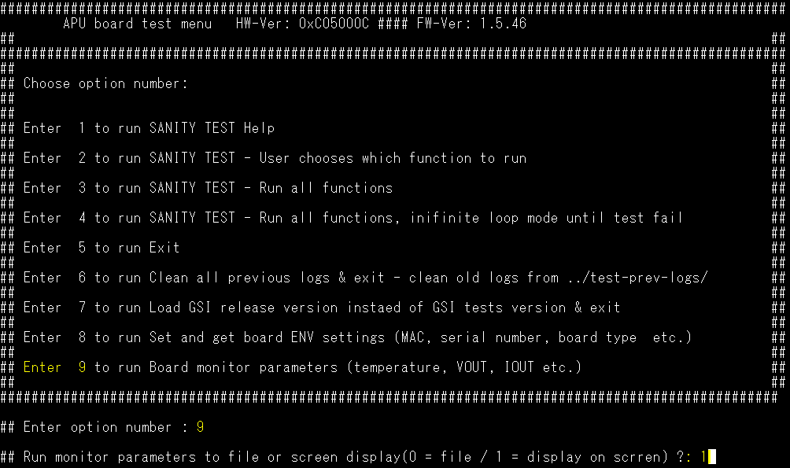

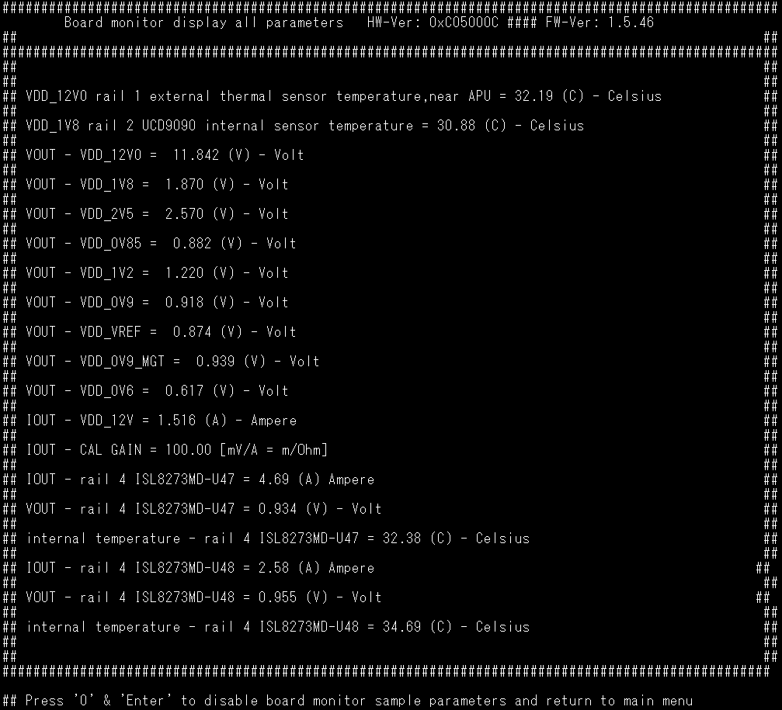

Pass criteria: Just record all the value on this version

VOUT - VDD_12V0 = 11.4~ 12.6

VOUT - VDD_1V8 = 1.71~1.89

VOUT - VDD_2V5 = 2.375~2.625

VOUT - VDD_0V85 = 0.808~0.892

VOUT - VDD_1V2 = 1.164~1.236

VOUT - VDD_0V9 = 0.85~1.0

VOUT - VDD_VREF = 0.814~0.865

VOUT - VDD_0V9_MGT = 0.855~0.945

VOUT - VDD_0V6 = 0.582 ~ 0.618

* + - 1. I2C device list check(on DUT)

Follow test4. , choose option 2, then choose option 24. Selecting ‘1’ for I2C device list check on bus 0 &1

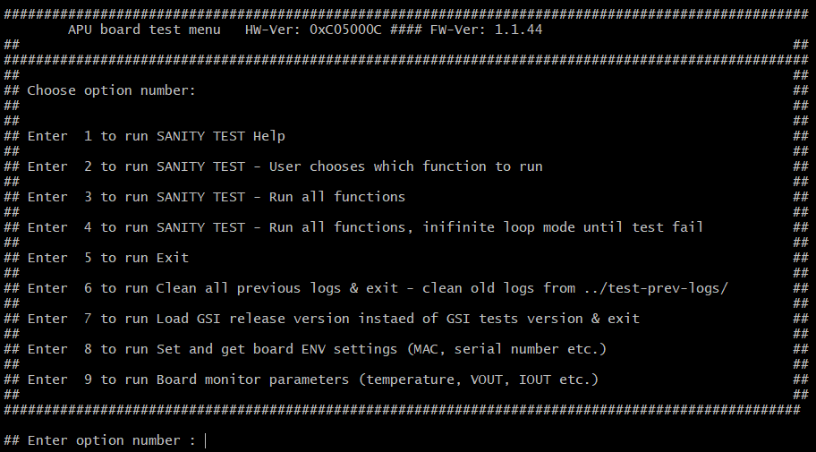

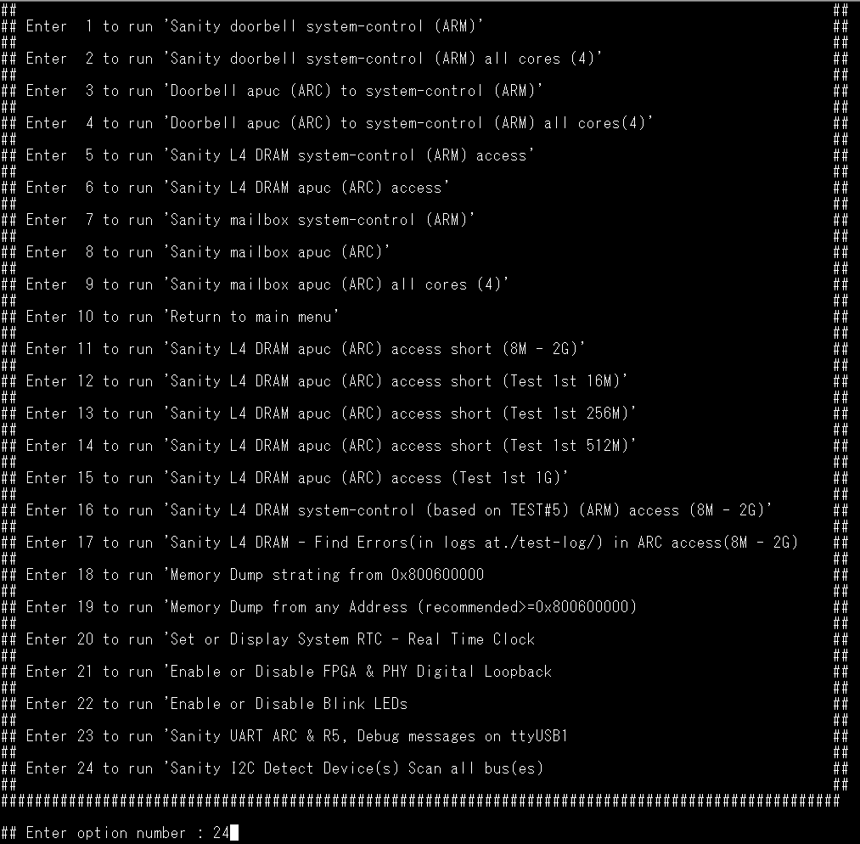

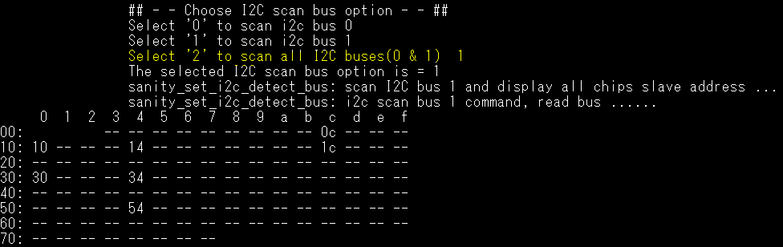

Pass criteria: The result should be as yellow marked as below.(10,14,1c,54)

sanity_set_i2c_detect_bus: i2c scan bus 1, read bus ......

0 1 2 3 4 5 6 7 8 9 a b c d e f

00: -- -- -- -- -- -- -- -- -- 0c -- -- --

10: 10 -- -- -- 14 -- -- -- -- -- -- -- 1c -- -- --

20: -- -- -- -- -- -- -- -- -- -- -- -- -- -- -- --

30: 30 -- -- -- 34 -- -- -- -- -- -- -- -- -- -- --

40: -- -- -- -- -- -- -- -- -- -- -- -- -- -- -- --

50: -- -- -- -- 54 -- -- -- -- -- -- -- -- -- -- --

60: -- -- -- -- -- -- -- -- -- -- -- -- -- -- -- --

70: -- -- -- -- -- -- -- --

* + - 1. RTC test(on DUT)

Follow test4. , choose option 2, then choose option 20.



Choose ‘1’ to set correct time and date. Time zone is UTC.

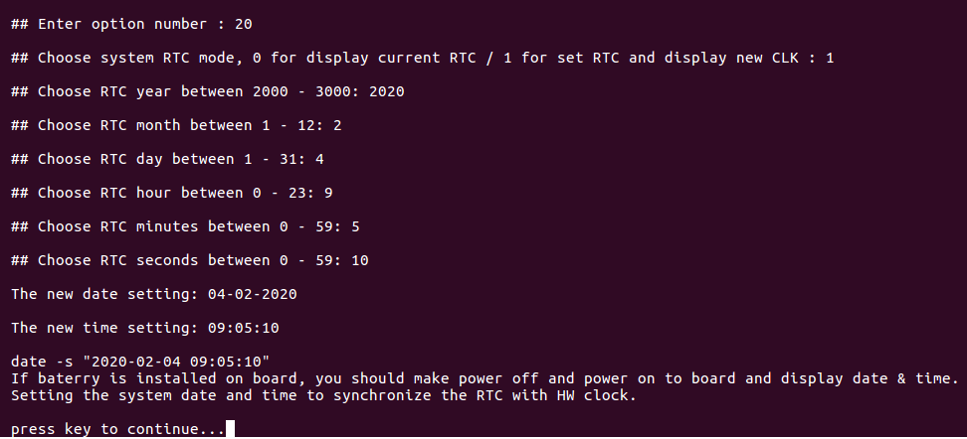

* + - 1. UART test(on DUT)

Follow test4. , choose option 2, then choose option 23 and input 1 for UART RX test

Note: SW3 DIP switch PIN7 must be on for this test item.



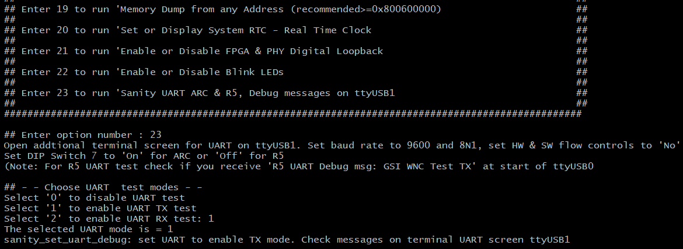

The message “GSI WNC Test TX” send to terminal ttyUSB1.

Check the ttyUSB1, if the message “GSI WNC Test TX” as below, the test is pass.

Below is the ttyUSB1 message.

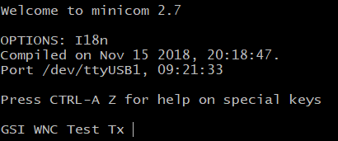

If the message “GSI WNC Test TX” is shown in the ttyUSB1, then input 1 in the ttyUSB0 to pass the UART test.



# Burn-In

Solder Paste

Prepare Material

SPI

SMT Process

AOI

X-Ray

ICT

Assembly

Burn-In

PCBA Functional Test

FQC

Ship

Packing

Final Test

* 1. Test Equipment List of Burn-In

|  |  |  |  |  |
| --- | --- | --- | --- | --- |
| ***Item*** | ***Equipment*** | ***Specification*** | ***Qty*** | ***Remark*** |
|  | PC | OS：Windows win 10 64bit | 1 | Driver: CP210x_Universal Driver |
|  | PSU | 12V DC Power for DUT | 1 |  |
|  | Power Cable | Sata to PCIe Power cable | 1 |  |
|  | Barcode Scanner | 2D | 1 |  |
|  | RJ45 Cable | Ethernet Cable 3m | 1 |  |
|  | Jumper | 2.0 mm jumper | 1 |  |
|  | USB HUB |  | 3*8 |  |
|  | Ethernet HUB |  | 3*8 |  |

* 1. List of Test Items

|  |  |  |  |
| --- | --- | --- | --- |
| **Item** | **Test Feature** | **Detailed Description** | **Remark** |
|  | Check DIP SW3 setting | Booting up from eMMC, SW3 setting as below:  10 /9 /8 /7 /6 /5 /4 /3 /2 /1 OFF/ON/OFF/ON/ON/OFF/ON/OFF/OFF/ON | 15.2.1.1 |
|  | Insert the jumper on J5 | Inserting the 2.0 jumper on J5 | 15.2.1.2 |
|  | Power on DUT | The DUT will enter the infinite burn-in test mode when the jumper is inserted on J5, then power on the DUT. | 15.2.1.3 |
|  | Test Pass Criteria | Running: LED (LD2) is blink  Finish: LED (LD2) is dark.  Failed: LED (LD2) is light. | 15.2.1.4 |

* + 1. Test Items screenshot
       1. SW3 DIP switch setting(on DUT)

If the system can’t boot up, then please disassemble the HeatSink and check the SW3 configuration.

1 / 2 / 3 / 4 / 5 / 6 / 7 / 8 / 9 / 10

ON / OFF / OFF / ON / OFF / ON / ON / OFF / ON / OFF 

* + - 1. Insert the jumper on J5

Please make sure the 2.0mm jumper is well inserted on J5

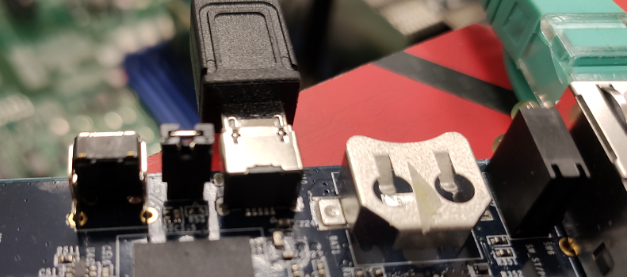

* + - 1. Power On DUT

When the 2.0mm jumper is inserted on J5, the DUT will run the burn-in test when power on the DUT automatically. Below is the screenshot when auto-test is running for reference.

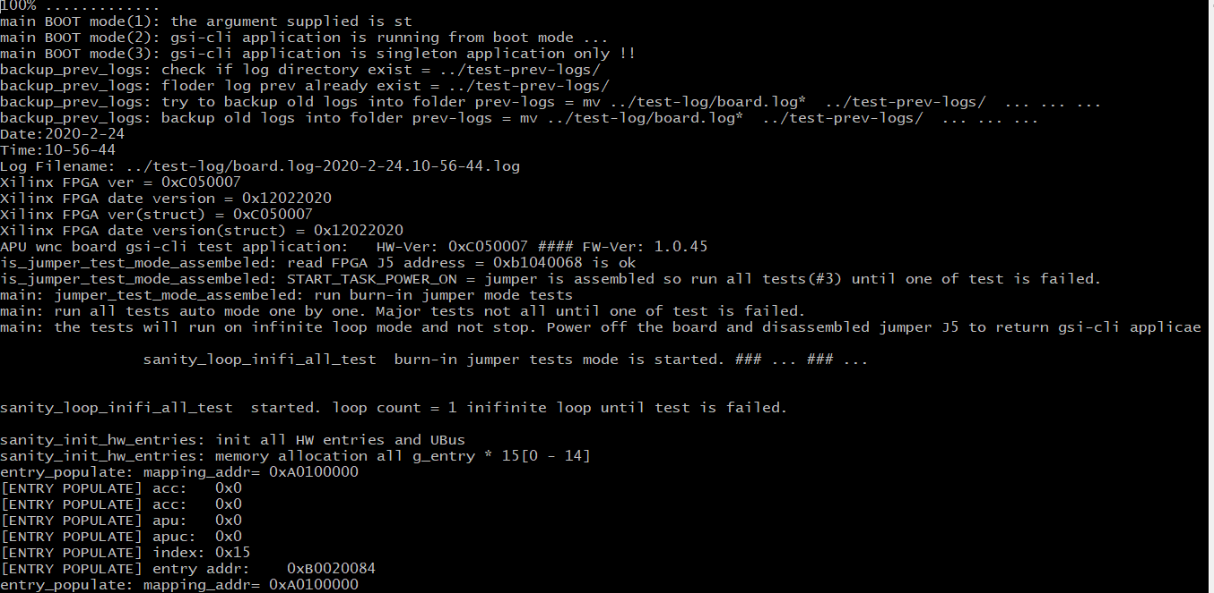

* + - 1. Test Pass Criteria(DUT)

When Burn-in is running, the indication LED (LD2) will be blink.

When Burn-in is failed, the indication LED (LD2) will be stopped blink and keep on.

When Burn-in is completed (no errors), the indication LED (LD2) will be stopped blink and keep off.

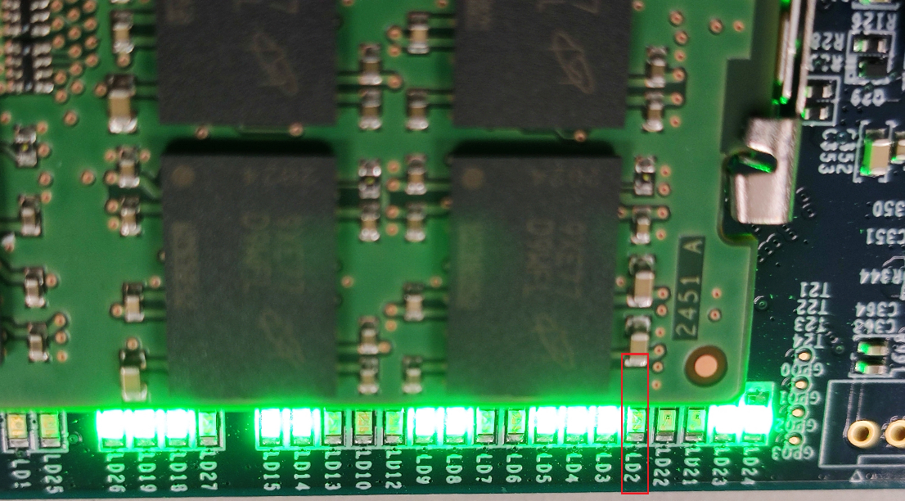

* 1. Test Environment of Burn-In Test

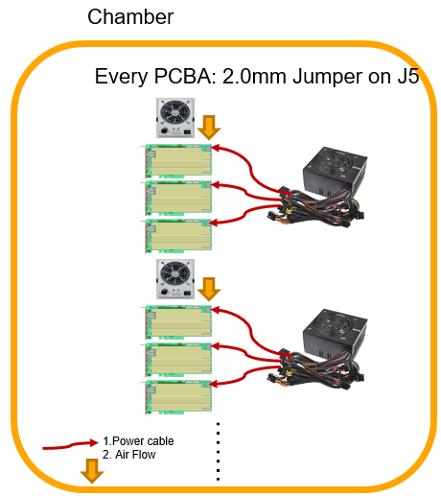

* 1. Operating Profile

The following are the detail of the burn-in profile:

|  |  |  |
| --- | --- | --- |
| Temp. Range (℃) | Test Cycles | Test Time (hrs) |
| 40 | infinite | 8 hours for EPR/4 hours for MP |

* 1. Test Requirement of Burn-In Test

|  |  |  |  |
| --- | --- | --- | --- |
| **Item** | **Test Feature** | **Detailed Description** | **Pass/Fail** |
|  | Check DIP SW3 setting | Booting up from eMMC, SW3 setting as below:  1 /2 /3 /4 /5 /6 /7 /8 /9 /10  ON/OFF/OFF/ON/OFF/ON/ON/OFF/ON /OFF |  |
|  | Jumper check on J5 | Insert 2.0mm Jumper on J5 |  |
|  | Test will be stop after 8hr | Checking the LED(LD2) as 15.2.14 description |  |
|  | Remove the J5 when Burn-In test is finished | The J5 jumper must be removed before run the Final Function Test |  |

# Final Functional Test

Solder Paste

Prepare Material

SPI

SMT Process

AOI

X-Ray

ICT

Assembly

PCBA Functional Test

Wavesolder

Process

Burn-In

Final Functional

Test

FQC

Packing

Ship

* 1. Test Equipment List of Final Functional Test

|  |  |  |  |  |
| --- | --- | --- | --- | --- |
| ***Item*** | ***Equipment*** | ***Specification*** | ***Qty*** | ***Remark*** |
| 1 | PC | 1. OS: Ubuntu 16.04 or 18 LTS 2. HW spec.:   PCIe Gen.3 X16  BIOS support: Above 4GB decoding   1. This compute must access the internet for package update | 1 | The Ubuntu update package:  sudo apt install dialog  sudo update-pciids  Driver: CP210x_Universal Driver |
| 2 | Barcode Scanner | 2D | 1 |  |
| 3 | Com port setting | Baud: 115200, HW SW flow control “NO” |  |  |
| 3 | PCIe Hotswap Card | PEX-16-50185 | 1 |  |
| 4 | PCIe Extenend Card | PEX-16XL V3.0 | 1 |  |
| 5 | RJ45 Cable | Ethernet Cable 3m | 1 |  |
| 6 | Console Cable | USB type-A to Micro-USB console cable | 1 |  |
| 7 | DHCP server | Need a DHCP server for DUT to do Ethernet test | 1 |  |

* 1. Test Items of Final Functional Test

|  |  |  |  |
| --- | --- | --- | --- |
| **Item** | **Test Feature** | **Detailed Description** | **Remark** |
|  | J5 Jumper check | The jumper must be removed from J5 | 16.2.1.1 |
|  | Ethernet Test | Ethernet connection test | 16.2.1.2 |
|  | Delete all Burn-In test log | The Burn-In test log must be deleted before Final function test to prevent the “upgrade-to-release” fail issue | 16.2.1.3 |
|  | Software version check | To check the GSI software version | 16.2.1.4 |
|  | RTC check | Read the RTC time is the same as server time | 16.2.1.5 |
|  | Run standalone test program | Run the GSI standalone test program | 16.2.1.6 |
|  | MAC and serial number check | Choose option 8 as test4, then option4 for check the MAC and serial setting in test6 and test7 | 16.2.1.7 |
|  | Test2- option11 | L4 to ARC. Choose PS and option #4 128MB | 16.2.1.8 |
|  | Test2-option16 | L4 to ARM. Choose PS and option #5 256MB | 16.2.1.9 |
|  | Test2-option4 | DB ARC to ARM all cores | 16.2.1.10 |
|  | Test2-option2 | DB ARM all cores | 16.2.1.11 |
|  | Test2-option9 | mailbox ARC all cores | 16.2.1.12 |
|  | Test2-option22 | Check LEDs LD2, LD3, LD4,LD5, LD8, LD9, LD10 | 16.2.1.13 |
|  | Clean Sever test log | To prevent the Sever be crashed, clean the log before next test item | 16.2.1.14 |
|  | PCIe test for L4 all 14GB RAM | The first 2 boards must run this item | 16.2.1.15 |
|  | PCIe test for L4 512MB test |  | 16.2.1.16 |
|  | Upgrade to release version | select option #7 Load GSI release version on main menu | 16.2.1.17 |

* + 1. Test Items screenshot
       1. No Jumper on J5

Please make sure there is no jumper on J5.

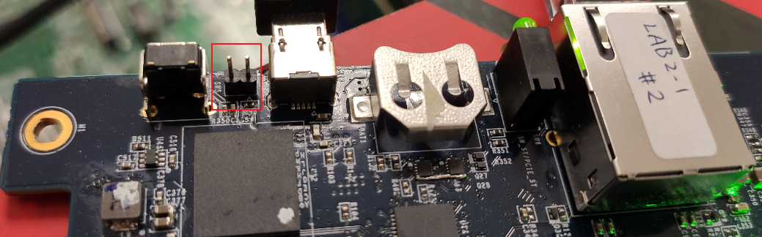

* + - 1. Ethernet Test(on DUT)

You could press <Ctrl-C> to stop load gsi-cli application (when you see 15% … , 50% icons on screen and so on).



#ifconfig

Please confirm that the IP address is the same network domain as the PC we use.

Ex: PC IP address: 192.168.33.60, DUT IP address:192.168.33.125



#ping 192.168.33.60 –C 10

The test result must be 0% packet lost as below.



After finished this test, run below command to make sure the test program is not running.

#sh /run/media/mmcblk0p1/scripts/stop_gsi_cli_test_app.sh

* + - 1. Delete all Burn-In test log

To prevent from the “upgrade-to-release” fail issue, we need to delete all Burn-In test log. The command is listed as below.

#cd /run/media/mmcblk0p1/test-log

#rm –rf *

#cd /run/media/mmcblk0p1/test-prev-logs/

#rm –rf *

#sync

* + - 1. Check Software Version(DUT)

#cat /run/media/mmcblk0p1/ version-image-gsi-tests-leda-e



- version-image: 17-mmcblk0p1

- BOOT.BIN-Profile ver: 1.15.07

- APU Sanity board test menu application ==> version: 1.5.46

- System version-run gsictl for help or gsictl -V

Package version=0.9.0.2

sys_boot version=0.4.0.11

fw_app version=0.9.0.2

sys_os version=0.3.2.0

apu_boot version=0.9.0.2

apu_kernel version=0.9.0.2

- system/apps for arc files and gsifw

- system/bin for gsictrl and run_app

- screen -r to see ubus traning last prints

- uEnv.txt for uboot env if not exist on flash.

- test-log for current tests logs

- test-prev-logs for backup logs

- image.ub and BOOT.BIN from se120_v3013_wnc

- R5-0_freertos_v20_uart_leds.elf

- hdf=fpga7_top_v53_burn_in_led.hdf

- HW version=0xC05000C

- Release version=100.11.05

- Release version_image=image.ub-100.11.0.6

* + - 1. OCP/OCW/OTP value check

Check command

#i2cget -f -y 1 0x19 0x46 w

0xea80

#i2cget -f -y 1 0x19 0x4a w

0xea40

#i2cget -f -y 1 0x19 0x4f w

0xeb98

#i2cget -f -y 1 0x19 0x21 w

0x2000

#i2cget -f -y 1 0x1A 0x46 w

0xea80

#i2cget -f -y 1 0x1A 0x4a w

0xea40

#i2cget -f -y 1 0x1A 0x4f w

0xeb98

#i2cget -f -y 1 0x1A 0x21 w

0x2000

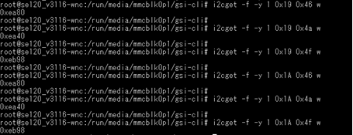

* + - 1. RTC check (on DUT)

#date



The RTC time spec. is +/-20 sec.

* + - 1. Run standalone test program(on DUT)

# cd /run/media/mmcblk0p1/gsi-cli/

# ./target-test



* + - 1. MAC, serial number, and board type check(on DUT)

Choose option 8, then chose option 4 for MAC, serial number, and board type checking





The serial number and MAC address must be the same as you did on 14.2.1.7 and 14.2.1.8.

* + - 1. L4 to ARC(on DUT)

Follow test7. , choose 2, then option 11, typing 0, then option#4 for 128MB testing



If test will passed, you should get ‘pass’ as below string.

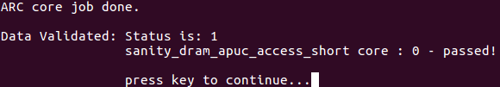

* + - 1. L4 to ARM(on DUT)

Follow test7. , choose 2, then option 16, typing 0, then option#5 for 256MB testing



If test will passed, you should get ‘test pass’ as below string.

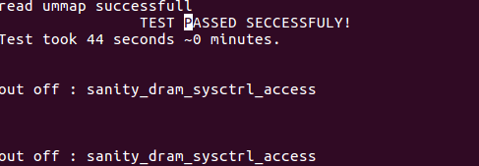

* + - 1. DB ARC to ARM all cores(on DUT)

Follow test7. , choose 2, then option 4



If test will be passed, you should get string “apu_id: 0 pass”, “apu_id: 1 pass”, “apu_id: 2 pass”, “apu_id: 3 pass”, as shown below.









* + - 1. DB ARM all cores(on DUT)

Follow test7. , choose 2, then option 2

If test will be passed, you should get string “apu_id: 0 pass”, “apu_id: 1 pass”, “apu_id: 2 pass”, “apu_id: 3 pass”, as shown below.









* + - 1. mailbox ARC all cores(on DUT)

Follow test7. , choose 2, then option 9



If test will be passed, you should get string “core number 0 test pass”, “core number 1 test pass”, “core number 2 test pass”, “core number 3 test pass” as shown below.

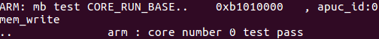



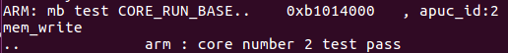

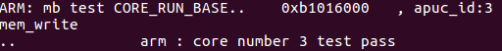

* + - 1. LED blink testing(on DUT)

Follow test7. , choose 2, then option 22 for LED blink test





In below screen, choose 1 then check PCBA LD2, LD3, LD4, LD5, LD8, LD9, LD10 blink

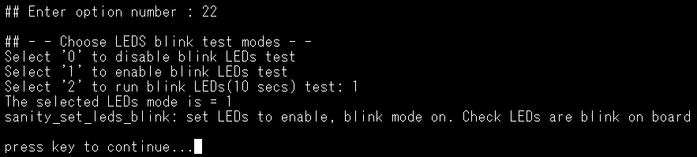

* + - 1. Clean the Server machine test log(on Server)

sudo rm /var/tmp/test-pci-conf/prev-logs/*

sudo rm /var/tmp/test-pci-conf/log/*

* + - 1. PCIe test for L4 all 14GB RAM (on Server)

Note:

1. Power off/on(or re-boot) the Server and DUT before this test.

2. Only first 5 boards must run this item.

3. The test program version is 1.4.57

cd /usr/local/bin/

sudo ./dialog-menu

The below scree will be popped up, then press Enter.

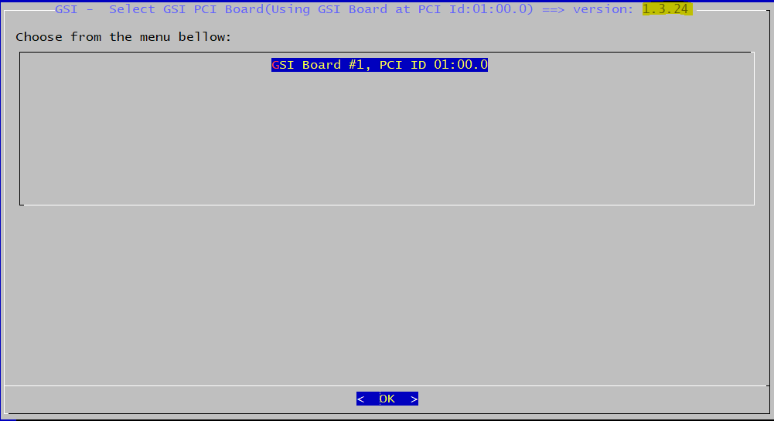

1.4.57

Choose DRAM L4 Tests

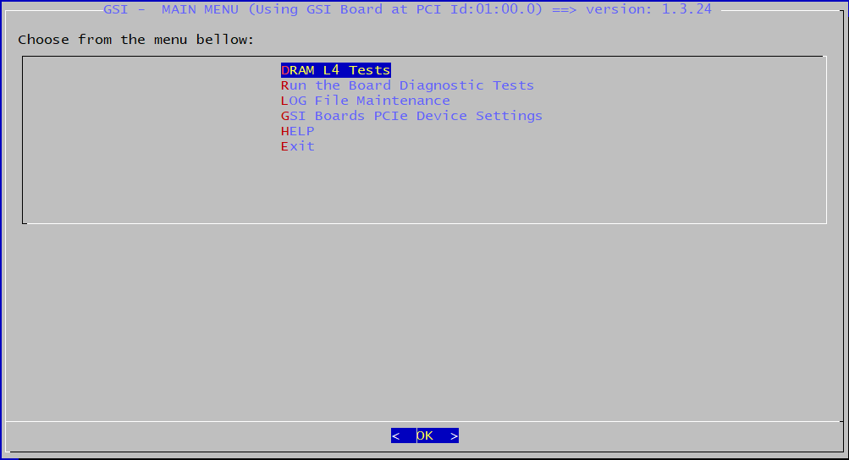

1.4.57

Choose DRAM PS-High Access (R/W) tests

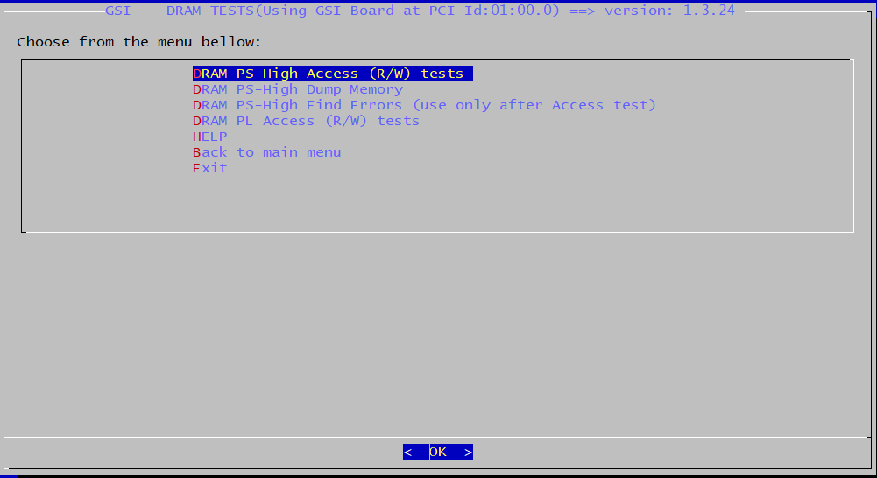

1.4.57

Choose 14GB Tests

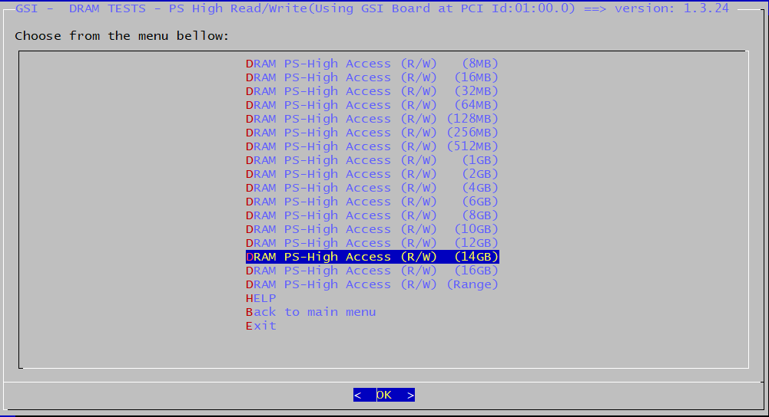

1.4.57

If the test is pass, then you will see the below message.

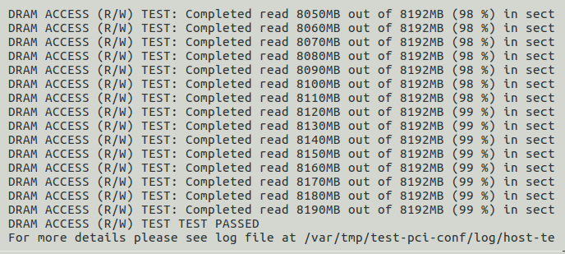

When all tests are completed and before you start new tests, you should clear all log files on the host server machine:

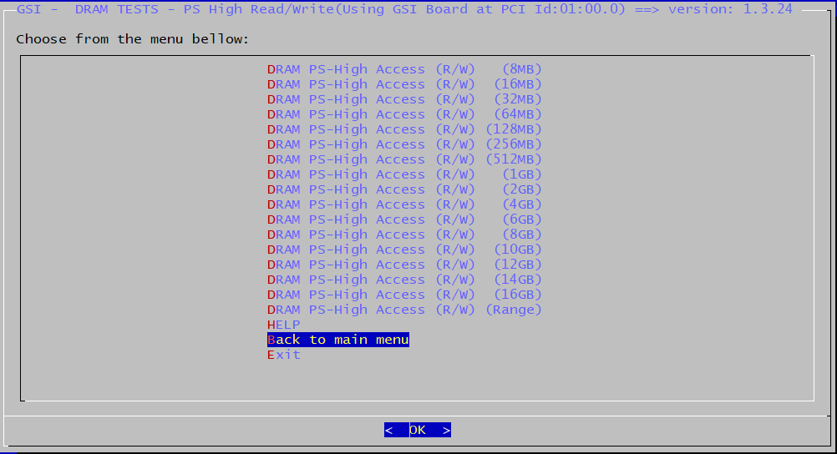

1.4.57

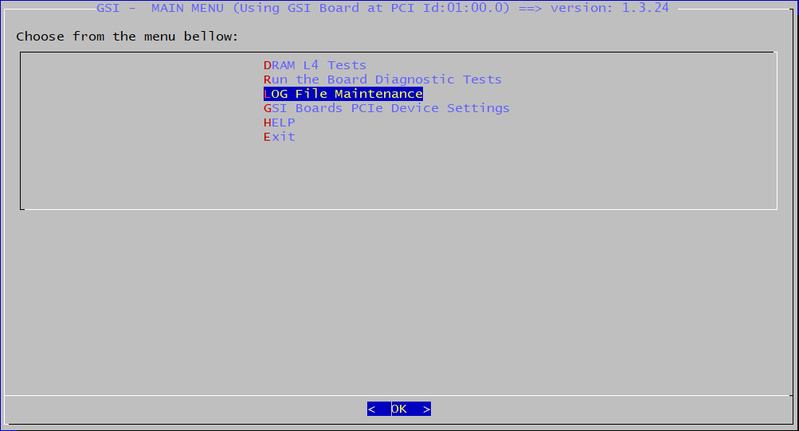

1.4.57

Select Clear All Logs from /var/tmp/test-pci-conf-/prev-logs.

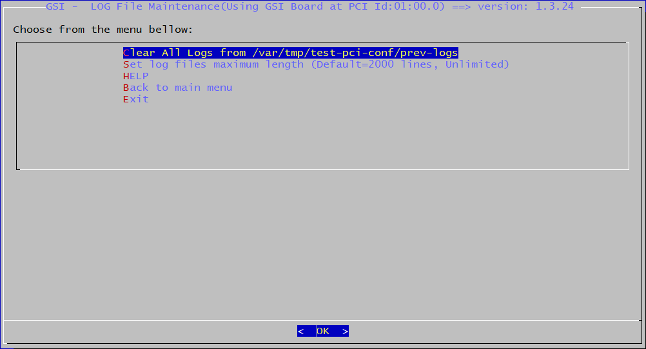

1.4.57

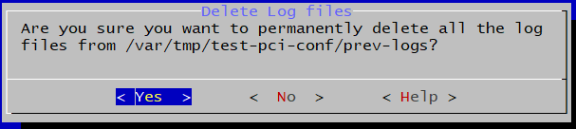

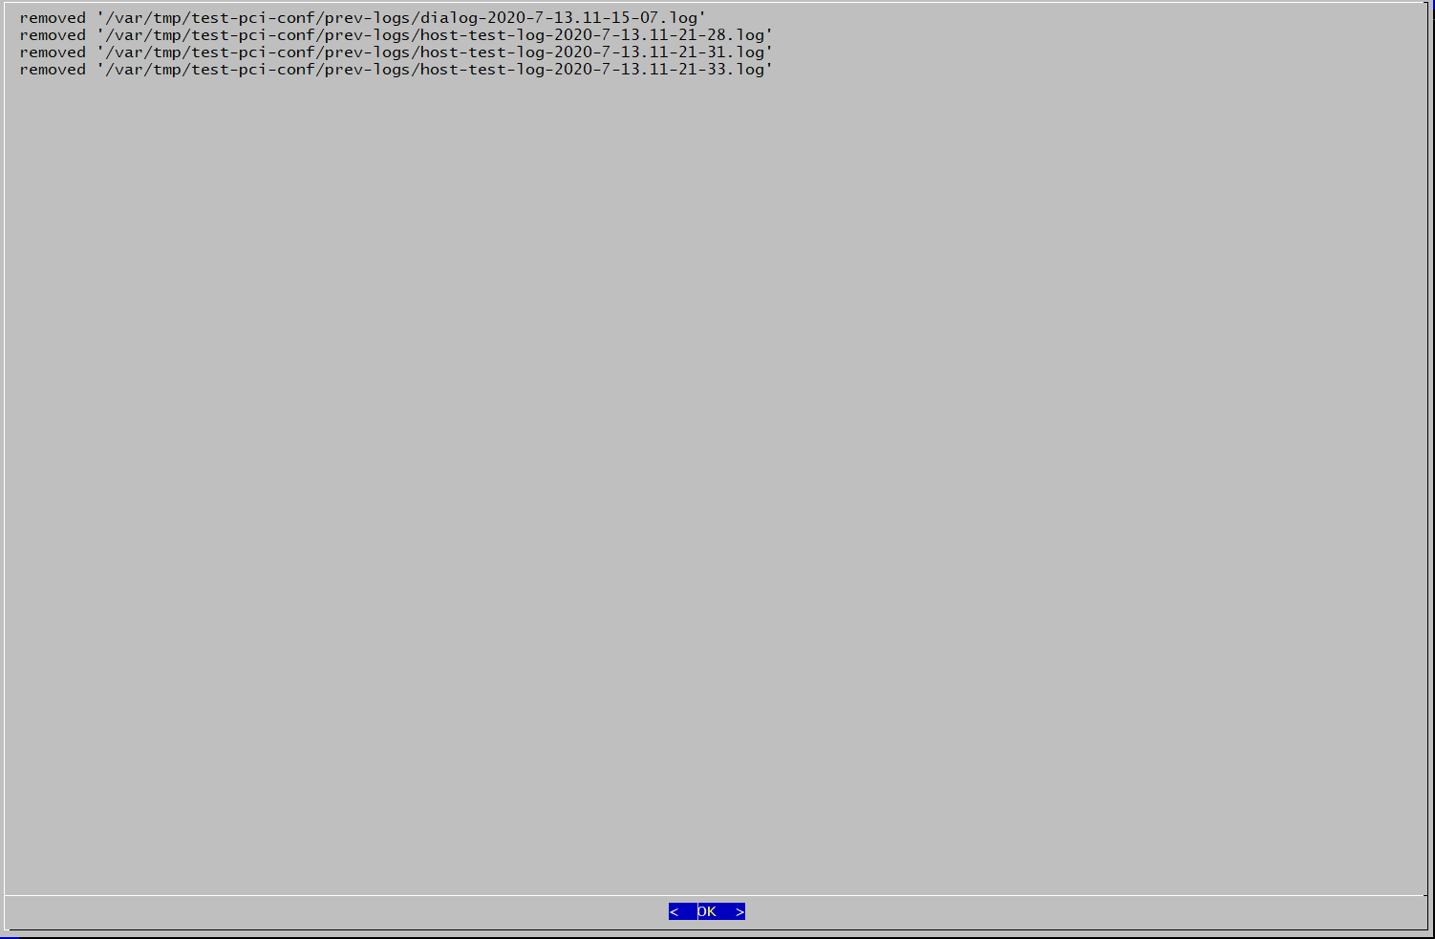

* + - 1. PCIe test for L4 512MB test (on Server)

Note:

1. Power off/on(or re-boot) the Server and DUT before this test.

cd /usr/local/bin/

sudo ./dialog-menu

The below scree will be popped up, then press Enter.



1.4.57

Choose DRAM L4 Tests



1.4.57

Choose DRAM PS-High Access (R/W) tests



1.4.57

Choosing 512MB Tests

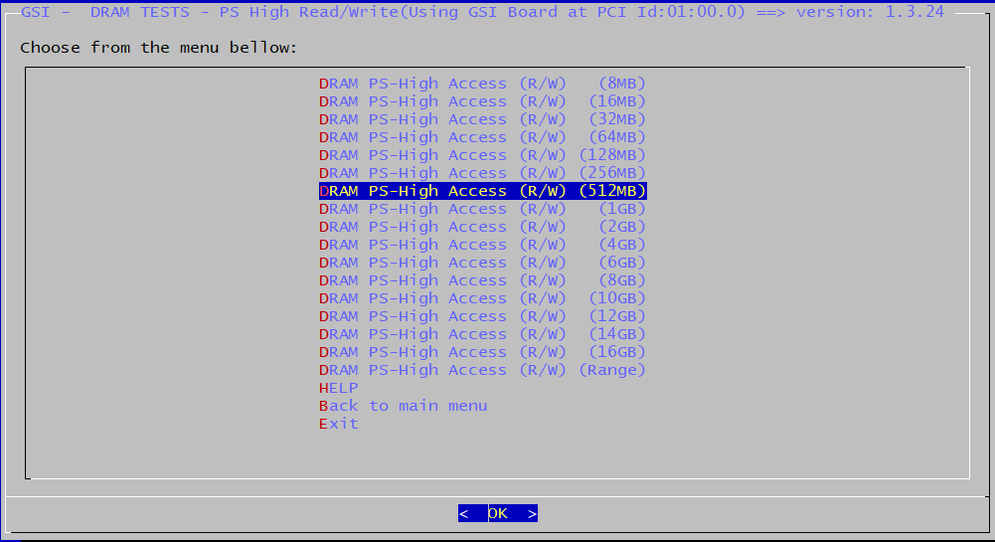

1.4.57

If the test is pass, then you will see the below message.



When all tests are completed and before you start new tests, you should clear all log files on the host server machine:



1.4.57



1.4.57

Select Clear All Logs from /var/tmp/test-pci-conf-/prev-logs.



1.4.57





* + - 1. Upgrade to release version(on DUT)

When all tests are completed and done with ‘Pass’ status you should upgrade current test GSI-CLI application into last release GSI version.

Select option ‘7’ “run Load GSI Release Version Instead Of GSI Tests Version & EXIT”

Choose ‘1’ to start upgrade to GSI release application

Go to directory /run/media and run “upgrade_to_release_ver.sh” script

Wait until process upgrade will done and power off / power on the board



Typing below command.

# cd /run/media

# ./upgrade_to_release_ver.sh



Wait until process upgrade will done and power off / power on the DUT.

Note: When the DUT show below error message, please input the command to recover the board.

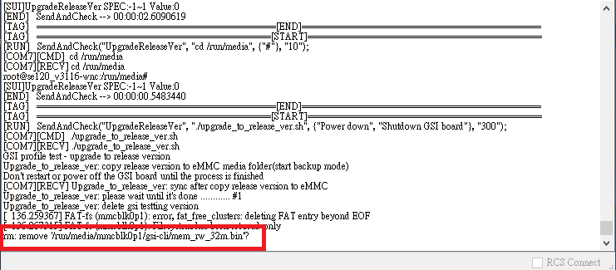

1. Ctrl+C
2. # mount -o remount, rw /run/media/mmcblk0p1
3. # mount -o remount
4. # cd /run/media
5. # ./upgrade_to_release_ver.sh
6. Wait until process upgrade will done and power off / power on the DUT.



* 1. Test Environment of Final Functional Test

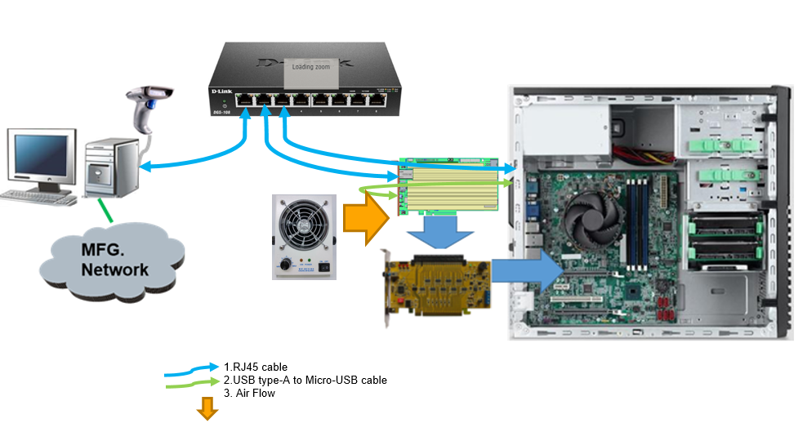

* 1. Test Requirements of Final Functional Test

|  |  |  |  |
| --- | --- | --- | --- |
| **Item** | **Test Feature** | **Detailed Description** | **Remark** |
|  | J5 Jumper check | The jumper must be removed from J5 | Pass/Fail |
|  | Ethernet Test | Ethernet connection test | Pass/Fail |
|  | Delete all Burn-In test log | The Burn-In test log must be deleted before Final function test to prevent the “upgrade-to-release” fail issue | Pass/Fail |
|  | Software version check | To check the GSI software version | Pass/Fail |
|  | RTC check | Read the RTC time is the same as server time | Pass/Fail |
|  | Run standalone test program | Run the GSI standalone test program | Pass/Fail |
|  | MAC and serial number check | Choose option 8 as test4, then option4 for check the MAC and serial setting in test6 and test7 | Pass/Fail |
|  | Test2- option11 | L4 to ARC. Choose PS and option #4 128MB | Pass/Fail |
|  | Test2-option16 | L4 to ARM. Choose PS and option #5 256MB | Pass/Fail |
|  | Test2-option4 | DB ARC to ARM all cores | Pass/Fail |
|  | Test2-option2 | DB ARM all cores | Pass/Fail |
|  | Test2-option9 | mailbox ARC all cores | Pass/Fail |
|  | Test2-option22 | Check LEDs LD2, LD3, LD4,LD5, LD8, LD9, LD10 | Pass/Fail |
|  | Clean Sever test log | To prevent the Sever be crashed, clean the log before next test item | Pass/Fail |
|  | PCIe test for L4 all 14GB RAM | The first 2 boards must run this item | Pass/Fail |
|  | PCIe test for L4 512MB test |  | Pass/Fail |
|  | Upgrade to release version | select option #7 Load GSI release version on main menu | Pass/Fail |

# FQC

Solder Paste

Prepare Material

SPI

SMT Process

AOI

X-Ray

ICT

Assembly

PCBA Functional Test

Wavesolder

Process

Burn-In

Final Functional

Test

FQC

Packing

Ship

* 1. Test Equipment of FQC

**DUT:**

|  |  |  |  |  |
| --- | --- | --- | --- | --- |
| **Item** | **Equipment** | **Specification** | **Qty** | **Remark** |
| 1 | PC | 1. OS: Ubuntu 16.04 or 18 LTS 2. HW spec.:   PCIe Gen.3 X16  BIOS support: Above 4GB decoding   1. This compute must access the internet for package update | 1 | The Ubuntu update package:  sudo apt install dialog  sudo update-pciids  Driver: CP210x_Universal Driver |
| 2 | Barcode Scanner | 2D | 1 |  |
| 3 | Com port setting | Baud: 115200, HW SW flow control “NO” |  |  |
| 3 | PCIe Hotswap Card | PEX-16-50185 | 1 |  |
| 4 | PCIe Extenend Card | PEX-16XL V3.0 | 1 |  |
| 5 | RJ45 Cable | Ethernet Cable 3m | 1 |  |
| 6 | Console Cable | USB type-A to Micro-USB console cable | 1 |  |
| 7 | DHCP server | Need a DHCP server for DUT to do Ethernet test | 1 |  |

* 1. List of Test Items

|  |  |  |  |
| --- | --- | --- | --- |
| **Item** | **Test Feature** | **Detailed Description** | **Remark** |
|  | Ethernet Test | Ethernet connection test and MAC address check | 17.2.1.1 |
|  | RTC check | Read the RTC time is the same as server time | 17.2.1.2 |
|  | Clean Sever test log | To prevent the Sever be crashed, clean the log before next test item | 17.2.1.3 |
|  | Verify the release version installed and run OK | To verify release version is installed and run OK. | 17.2.1.4 |

* + 1. Test items screenshot
       1. QSPI code erase(on DUT, Golden sample doesn’t run this test)

“Hit any key to stop autoboot: 4”, Press ‘enter’ to stop uboot into prompt.



If it is successful to stop at u-boot command line mode, the screen will be as below.



Press ‘sf probe 0 0 0’ to probe the QSPI device, command is shown as below.

ZynqMP> sf probe 0 0 0

Press ‘sf erase 0 2060000’ to erase the QSPI code, command is shown as below.

ZynqMP> sf erase 0 2060000

If the erase is finished as below, then press ‘reset’ to reboot the system to Linux for next test.

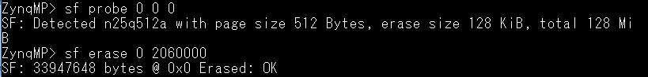

* + - 1. Ethernet Test(on DUT)

Note: The first time to boot will take about 60sec.

#ping 192.168.33.60 –c 10

The test result must be 0% packet lost as below.



* + - 1. RTC check (on DUT)

#date



The RTC time spec. is +/-40sec.

* + - 1. Clean the Server machine test log(on Server)

sudo rm /var/tmp/test-pci-conf/prev-logs/*

sudo rm /var/tmp/test-pci-conf/log/*

* + - 1. Verify the release version installed and run OK(on Server)

Note: Power off/on(or re-boot) the Server and DUT before this test.

cd /usr/local/bin/

sudo ./dialog-menu

The below scree will be popped up, then press Enter.

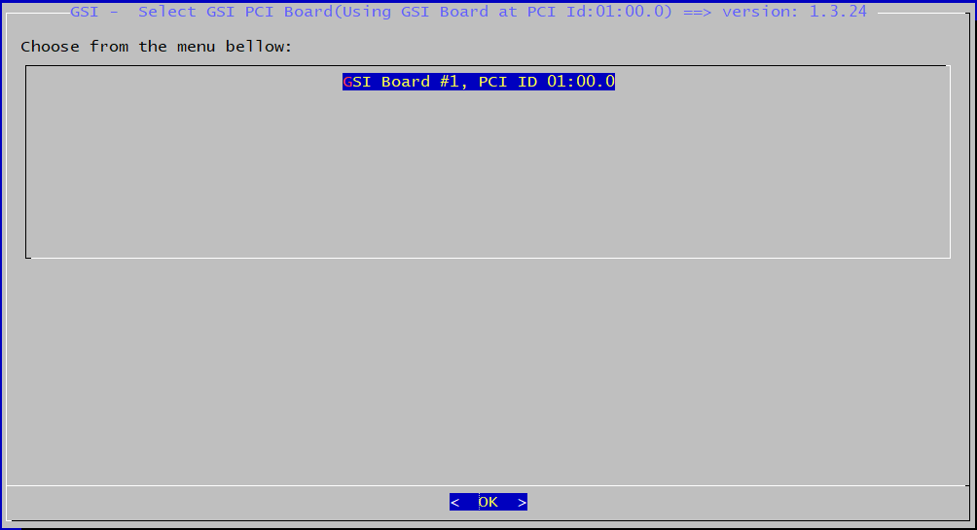

1.4.57

The below scree will be popped up, select the “Run the Board Diagnostic Tests, then press Enter.

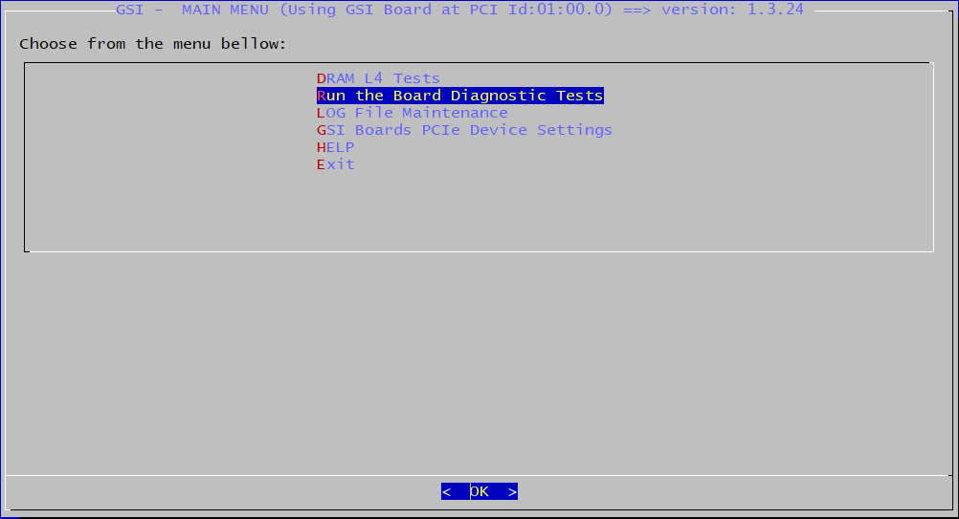

1.4.57

The below scree will be popped up, press Enter.

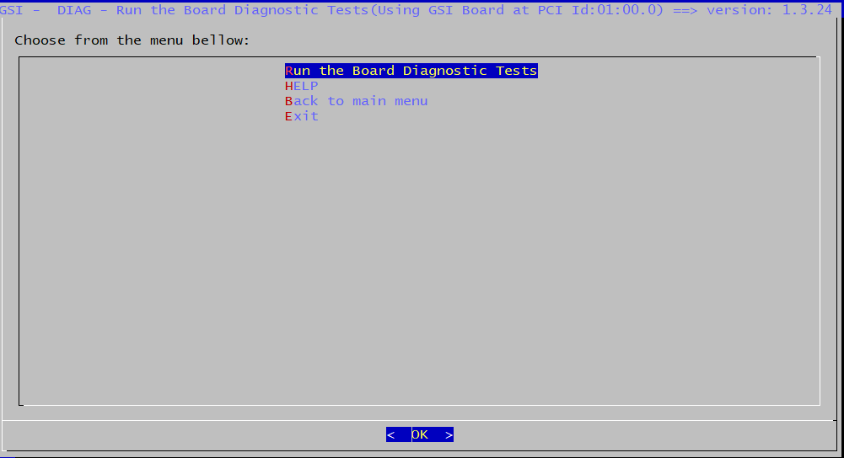

1.4.57

The below scree will be popped up, press Enter.

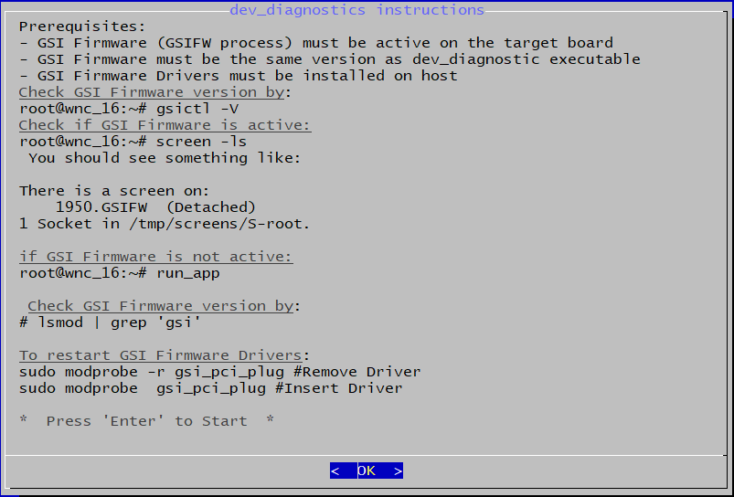

You could get the message “Test Result PASS” if test ok.

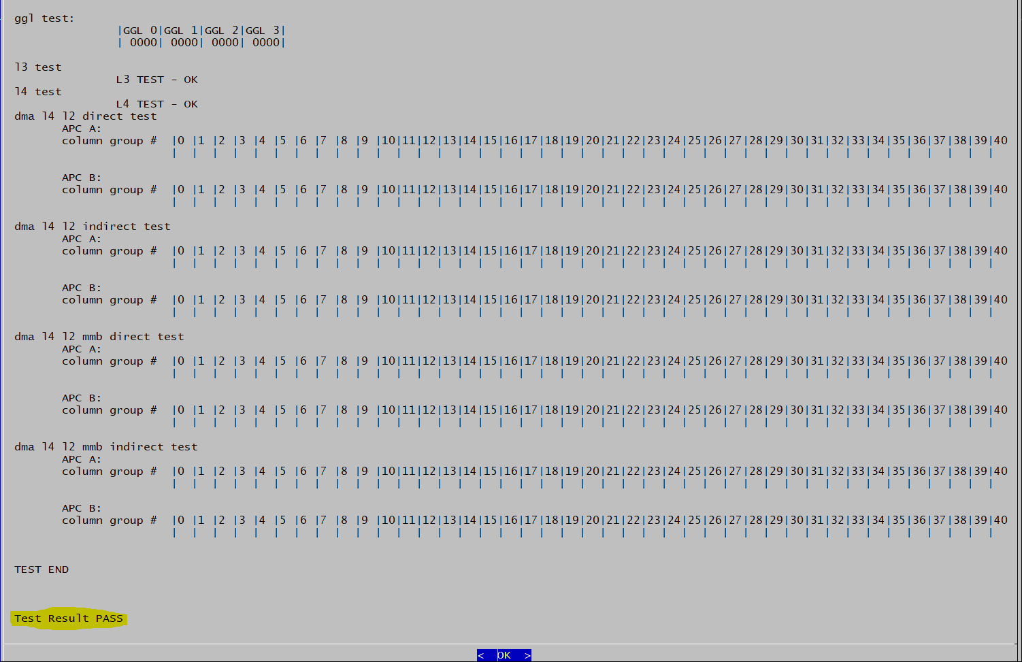

* 1. Test Environment of FQC

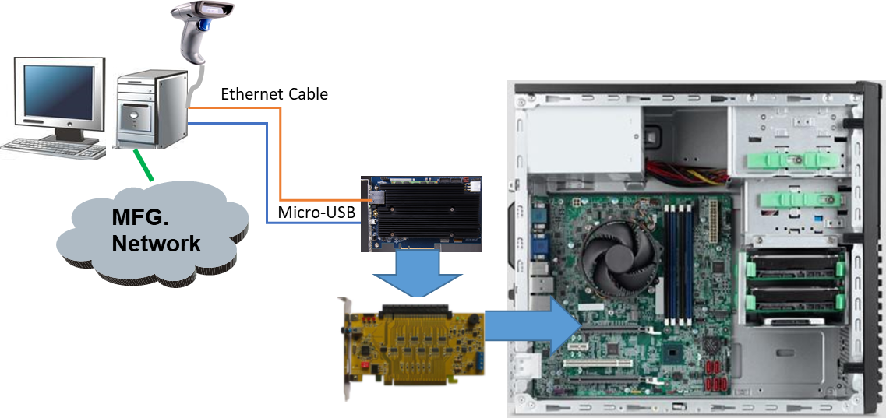

* 1. Test Requirements of FQC

|  |  |  |  |
| --- | --- | --- | --- |
| **Item** | **Test Feature** | **Detailed Description** | **Pass/Fail** |
|  | Check SW3 setting  Before any test | Booting up from eMMC, SW3 setting as below:  1 /2 /3 /4 /5 /6 /7 /8 /9 /10  ON/OFF/OFF/ON/OFF/ON/ON/OFF/ON /OFF |  |
|  | Ethernet Test and MAC address check | Ethernet connection test |  |
|  | RTC check | Read the RTC time is the same as server time |  |

# Firmware Upgrade

When board is burn and running on eMMC with version for example: image 08-mmcblkop1.tar.gz and gsi-cli test version is 1.0.28(You could see it on gsi-cli top menus) and new version is released. If you need to upgrade the new firmware, you should follow below procedure.

* 1. Equipment for Firmware Upgrade

|  |  |  |  |  |
| --- | --- | --- | --- | --- |
| **Item** | **Equipment** | **Specification** | **Qty** | **Remark** |
|  | PC | OS：Windows win 10 64bit | 1 | Driver: CP210x_Universal Driver  New release Firmware: ##-mmcblk0p15.tar.gz  DHCP/FTP server SW: tftpd64.450 |
|  | Com port setting | Baud: 115200, HW SW flow control “NO” |  |  |
|  | RJ45 Cable | Ethernet Cable 3m | 1 |  |
|  | Console Cable | USB type-A to Micro-USB console cable | 1 |  |
|  | PSU | 12V DC Power for DUT | 1 |  |
|  | Power Cable | Sata to PCIe Power cable | 1 |  |

* 1. Step by Step of how to upgrade the firmware
     + 1. Setup the DHCP server on the PC. (PC)

In this example, we set the DHCP server IP is 192.168.33.60. The server would assign the DUP IP as 192.168.33.125.



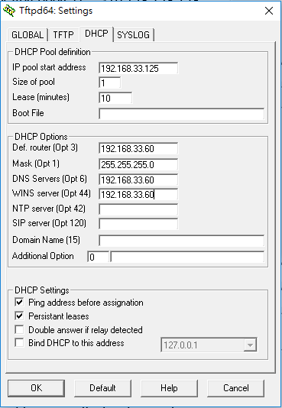

* + - 1. Setup the FTP server on the PC. (PC)

In this example, I placed the New release firmware in the folder D:\GSI\doc\18.SW\11-wnc-hw-tests on the PC. The FTP path must set the Directory as D:\GSI\doc\18.SW\11-wnc-hw-tests, so that the DUT could get the New release firmware from here.

Creating a file test.txt and content is firmware_test in the folder D:\GSI\doc\18.SW\11-wnc-hw-tests, it will be used to test the ftp download.

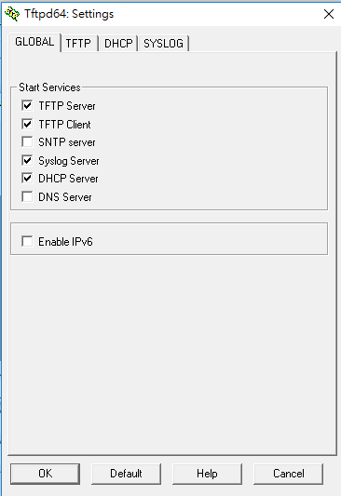

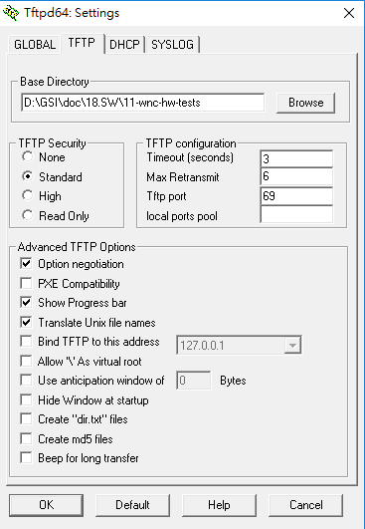

c

* + - 1. QSPI code prepare(PC)

QSPI2.bin must be saved in the D:\GSI\doc\18.SW\11-wnc-hw-tests.

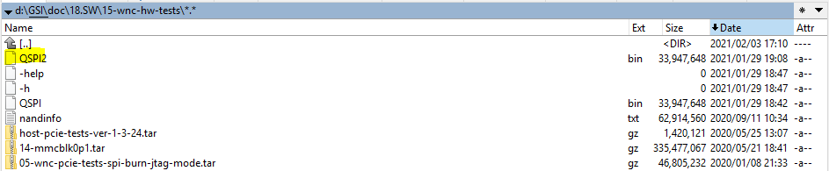

* + - 1. Programming the QSPI(DUT)

SW3 setting as below.

1 / 2 / 3 / 4 / 5 / 6 / 7 / 8 / 9 / 10

ON / OFF / ON / ON / OFF / ON / ON / OFF / ON / OFF

Power on the board, when you see the message “Hit any key to stop autoboot: 4”, Press ‘enter’ to stop uboot into prompt.



If it is successful to stop at u-boot command line mode, the screen will be as below.



Key in the below command

>sf probe 0 0 0

>tftpboot QSPI2.bin

>sf write 0x10000000 0 0x2060000

The result would be like below screen.

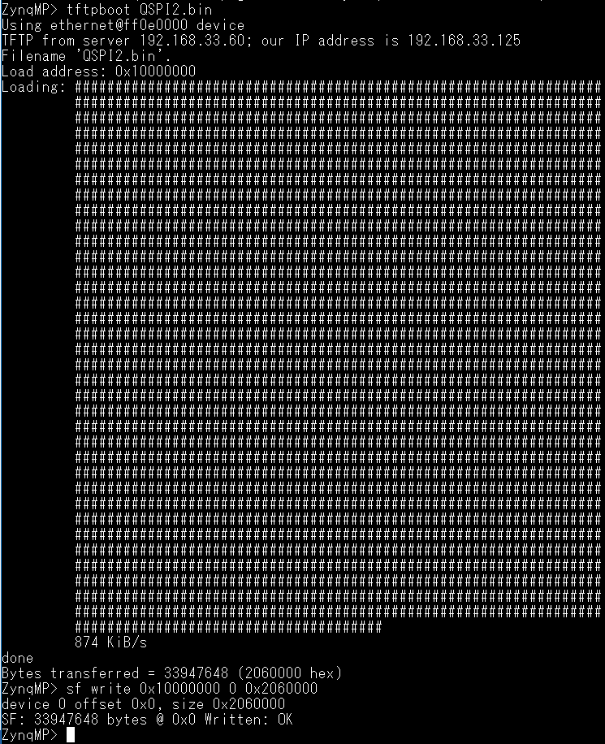

* + - 1. Boot from QSPI to program the eMMC code(DUT)

1. SW3 PIN3 ON

1 / 2 / 3 / 4 / 5 / 6 / 7 / 8 / 9 / 10

ON / OFF / ON / ON / OFF / ON / ON / OFF / ON / OFF

1. Power ON the board
2. see the console message and press "enter"key for stoping it in u-boot
3. key the command "bootm" for boot-up to linux
4. when you see "se_gsi_apu_18_wnc login:", user name is "root", Password is "root"
5. umount /dev/mmcblk0p3 /dev/mmcblk0p1 /dev/mmcblk0p2
6. run the below yellow marked command, you will see the related message as below.

root@se_gsi_apu_18_wnc:~# umount /dev/mmcblk0p3 /dev/mmcblk0p1 /dev/mmcblk0p2

root@se_gsi_apu_18_wnc:~# dd if=/dev/zero of=/dev/mmcblk0 bs=1024 count=1

1+0 records in

1+0 records out

root@se_gsi_apu_18_wnc:~# fdisk /dev/mmcblk0

Device contains neither a valid DOS partition table, nor Sun, SGI, OSF or GPT di sklabel

Building a new DOS disklabel. Changes will remain in memory only,

until you decide to write them. After that the previous content

won't be recoverable.

The number of cylinders for this disk is set to 116736.

There is nothing wrong with that, but this is larger than 1024,

and could in certain setups cause problems with:

1) software that runs at boot time (e.g., old versions of LILO)

2) booting and partitioning software from other OSs

(e.g., DOS FDISK, OS/2 FDISK)

Command (m for help): c

DOS Compatibility flag is not set

Command (m for help): u

Changing display/entry units to sectors

Command (m for help): c

DOS Compatibility flag is set

Command (m for help): n

Command action

e extended

p primary partition (1-4)

p

Partition number (1-4): 1

First sector (16-7471103, default 16): 16

Last sector or +size or +sizeM or +sizeK (16-7471103, default 7471103):

7471103

Command (m for help): a

Partition number (1-4): 1

Command (m for help): t

Selected partition 1

Hex code (type L to list codes): c

Changed system type of partition 1 to c (Win95 FAT32 (LBA))

Command (m for help): p

Disk /dev/mmcblk0: 3825 MB, 3825205248 bytes

4 heads, 16 sectors/track, 116736 cylinders, total 7471104 sectors

Units = sectors of 1 * 512 = 512 bytes

Device Boot Start End Blocks Id System

/dev/mmcblk0p1 * 16 7471103 3735544 c Win95 FAT32 (LBA)

Command (m for help): w

The partition table has been altered.

Calling ioctl() to re-read partition table

[ 96.632542] mmcblk0: p1

root@se_gsi_apu_18_wnc:~# sync

root@se_gsi_apu_18_wnc:~# reboot

1. repeat step3~5
2. run below yellow marked command

root@wnc_16:~# mkfs.vfat -F 32 -n boot /dev/mmcblk0p1

root@wnc_16:~# sync

root@se_gsi_apu_18_wnc:~# reboot

1. repeat step3~5
2. run below yellow marked command

root@se_gsi_apu_18_wnc: cd /run/media/mmcblk0p1

root@se_gsi_apu_18_wnc:/run/media/mmcblk0p1# rm -rf

root@se_gsi_apu_18_wnc:/run/media/mmcblk0p1# tftp -g -r 18-wnc-hw-tests-leda-e.tar.gz 192.168.33.60

root@se_gsi_apu_18_wnc:/run/media/mmcblk0p1# mkdir tmp

root@se_gsi_apu_18_wnc:/run/media/mmcblk0p1# tar -zxvf 18-wnc-hw-tests-leda-e.tar.gz -C tmp

root@se_gsi_apu_18_wnc:/run/media/mmcblk0p1# cp -r tmp/17-mmcblk0p1/* ./

root@se_gsi_apu_18_wnc:/run/media/mmcblk0p1# rm -r 18-wnc-hw-tests-leda-e.tar.gz tmp

root@se_gsi_apu_18_wnc:/run/media/mmcblk0p1# sync

* + - 1. Boot from eMMC(DUT)

1. SW3 PIN3 OFF

1 / 2 / 3 / 4 / 5 / 6 / 7 / 8 / 9 / 10

ON / OFF / OFF / ON / OFF / ON / ON / OFF / ON / OFF

2. Power ON the board

* + - 1. Environment of Firmware Update

